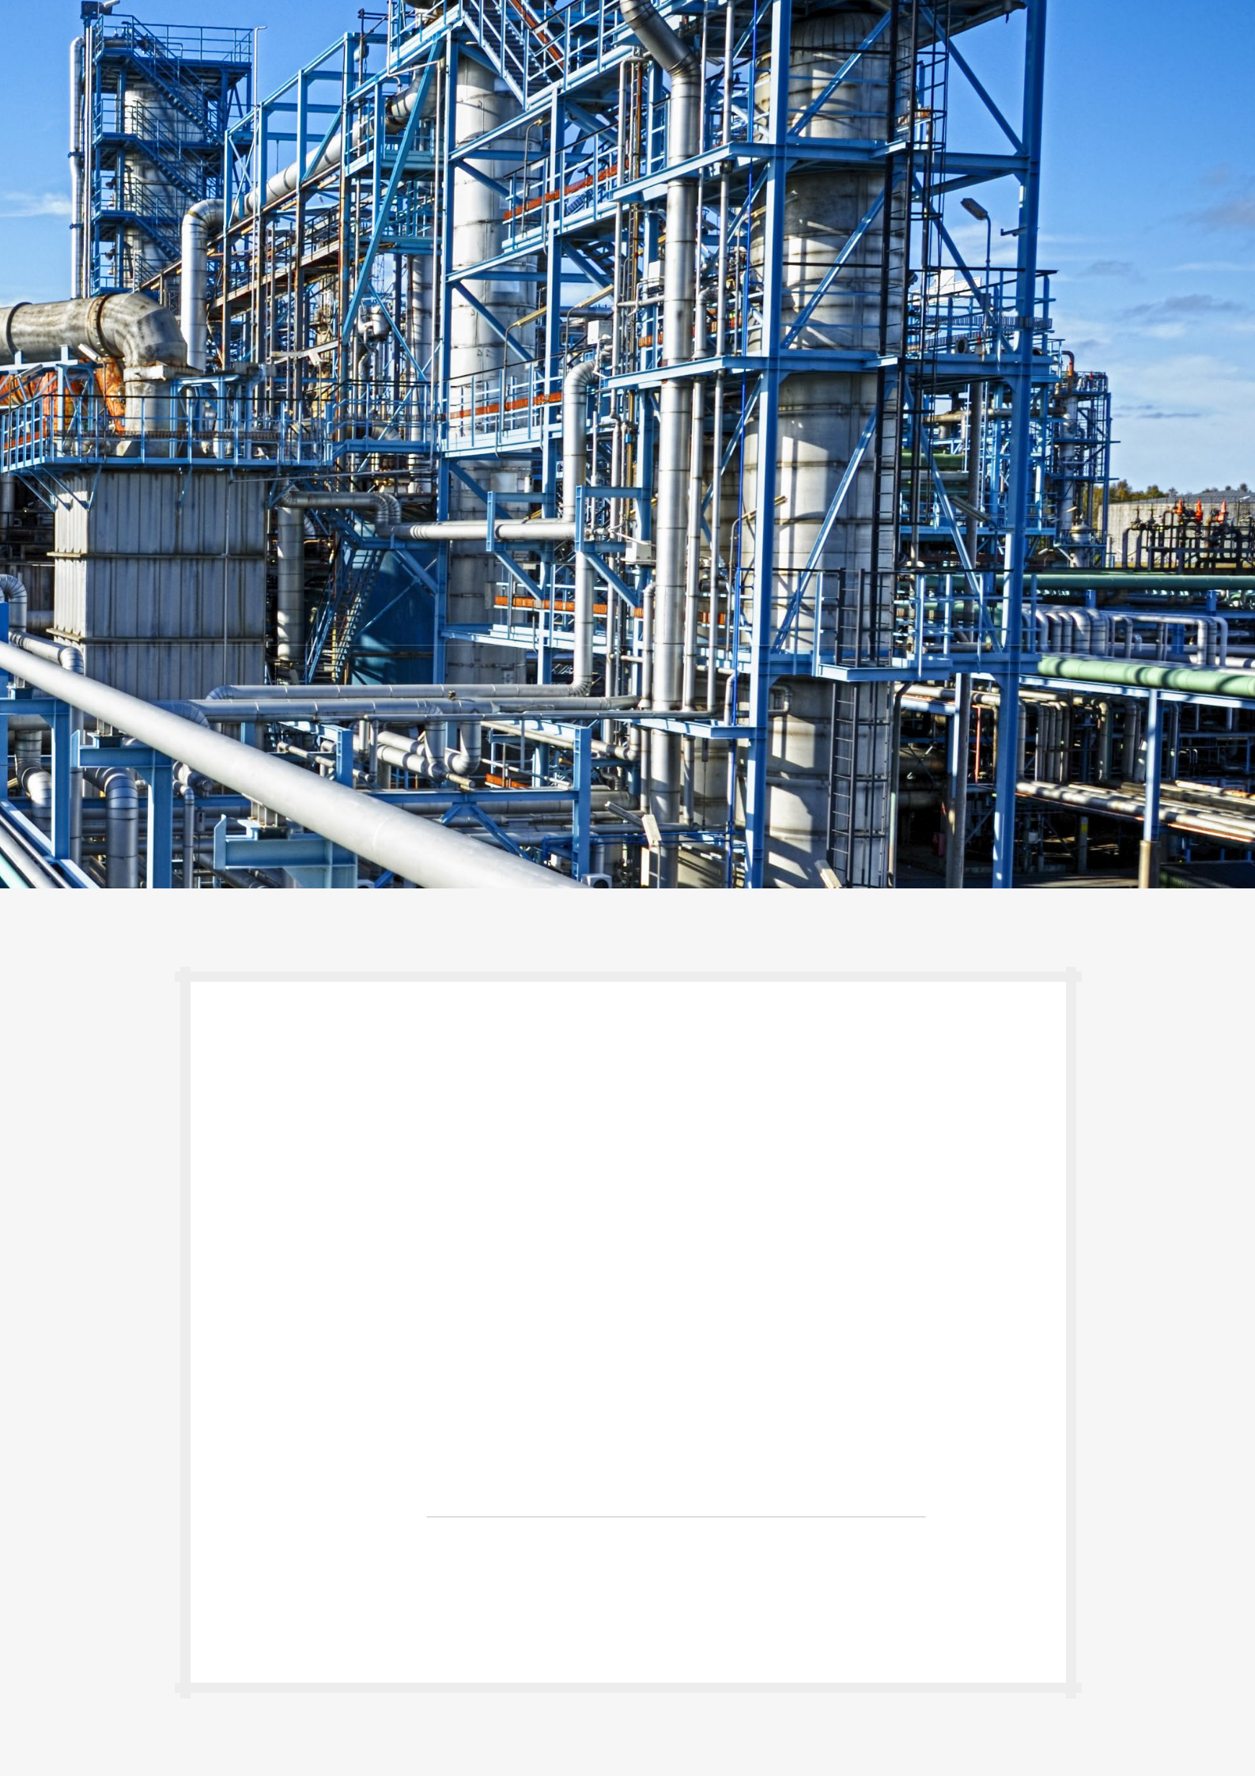

 |  | FASTENERS | MATTRESSES | TECHNIQUES

TAPE ALUFOIL 35000

 |  |  |  | Material: aluminium foil
 |  |  |  | Use: joining insulation materials and insulation
 |  |  |  | coated aluminium. Tape Alufoil 35000
 |  |  |  | provides unrivalled performance, maintaining
 |  |  |  | insulation efficiency by protecting against the
 |  |  |  | effects of fire, moisture and dust. The products
 |  |  |  | are easy to apply, exhibiting instant adhesion
 |  |  |  | and can be shaped to any profile. Product with
 |  |  |  | MED certificate.
 |  |  |  | Availability: in stock
 |  | PRODUCT CHARACTERISTICS
 |  | Finish | aluminum foil
 |  | Thickness | 25µ
 |  | Adhesive | rubber (synthetic rubber/resin)
 |  | Release paper | siliconised paper
 |  | Service temperature | from -10°C to +90°C
 |  | Apliccation temperature | -5°C (minimum)
 |  | Ultimate tensile strength (around) | 89 N/25mm
 |  | Elongation (around) | 8-11%
 |  | Peel adhesion to steel (around) | initial: 20-25 N/25mm
 |  |  | after 24h: 25-30 N/25mm
 |  |  | class 0 compliance
 |  | Fire resistance | fire resistance Independently tested to BS 476
 |  |  | part 6 and Part 7 – Class 1
 |  |  | at least 12 months from date of manufacture when
 |  | Shelf life/storage | stored in a dry place within the temperature range
 |  |  | +10°C and +30°C
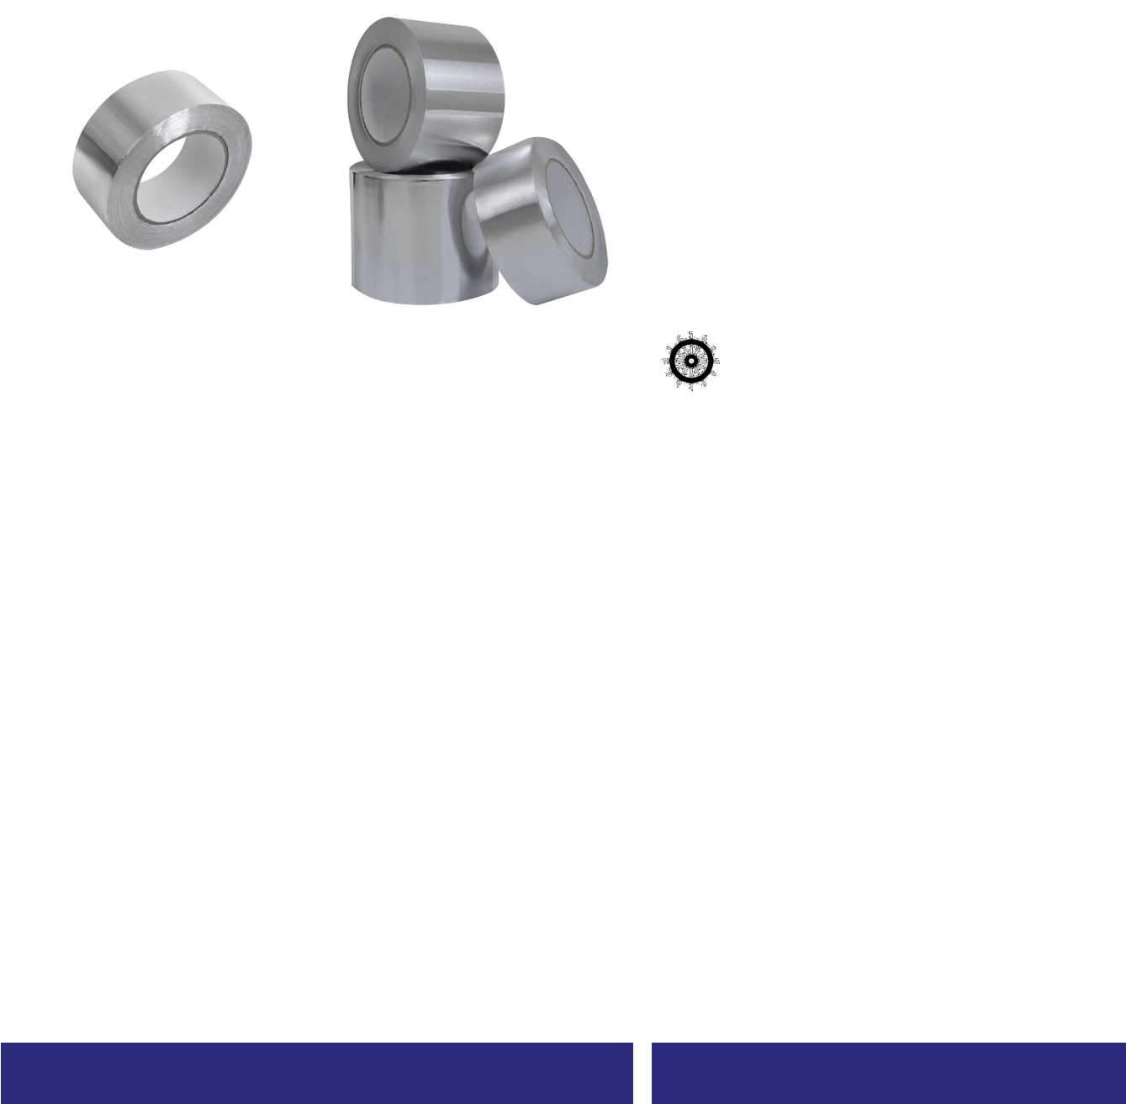

NAME

35000 50mm x 45mb

35000 75mm x 45mb

35000 100mm x 45mb

INDEX

T-01-001

T-01-002

T-01-003

ADDITIONAL INFORMATION

Surfaces to be bonded must be clean, dry and free from dust, grease and loose materials. If necessary, wipe surfaces sparingly with a cloth dampened with a ketone-free cleaner and allow to dry for at least an hour before tape application.

The butt joints of insulation sections should be positioned together without gaps to ensure an adequate bond. Select a tape width suitable for the application. A width of 50mm is suitable for closely positioned, flat sections. Otherwise, select a tape the thickness of the insulation plus 50 mm to allow for the exposed cut edge.

TAPES | FABRICS | INSULATION | INSULATION | FASTENING | SD STUDS CABLE TRAYS OTHERS
 |  | FASTENERS | MATTRESSES | TECHNIQUES

REINFORCED ALUMINIUM TAPE

Material: glass fibre, density 200 g/m2
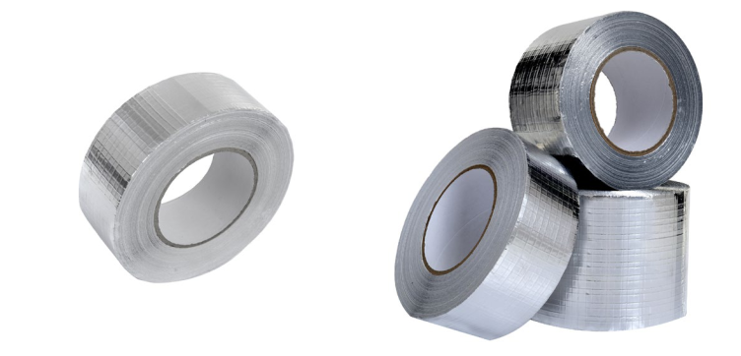

Use: joining insulation materials either aluminium coated or not. Embedded glass fibber mesh increases the mechanical strength. The applied adhesive allows application in winter conditions.

Availability: in stock

PRODUCT CHARACTERISTICS

Finish | aluminium foil
Thickness | 0,09mm; PSTC-133/ASTM D 3652
Adhesive | modified acrylic
Release paper | siliconised paper
Service temperature | from -35°C to +120°C
Apliccation temperature | from -20°C to +40°C
Ultimate tensile strength (around) | 120 N/25mm; PSTC-131/ASTM D 3759
Elongation (around) | 3%
Peel adhesion to steel (around) | 12 N/25mm; PSTC-131/ASTM D 3759
 | 6 month from date of manufacture when stored
Shelf life/storage | within the temperature range +20°C and +30°C
 | and 50% RH

NAME

Reinforced Alu Tape 50mm x 45mb

Reinforced Alu Tape 75mm x 45mb

Reinforced Alu Tape 100mm x 45mb

INDEX

T-01-004

T-01-005

T-01-006

ADDITIONAL INFORMATION

Surfaces to be bonded must be clean, dry and free from dust, grease and loose materials. If necessary, wipe surfaces sparingly with a cloth dampened with a ketone-free cleaner and allow to dry for at least an hour before tape application.

The butt joints of insulation sections should be positioned together without gaps to ensure an adequate bond. Select a tape width suitable for the application. A width of 50mm is suitable for closely positioned, flat sections. Otherwise, select a tape the thickness of the insulation plus 50 mm to allow for the exposed cut edge.

5

TAPES | FABRICS | INSULATION | INSULATION | FASTENING | SD STUDS CABLE TRAYS | OTHERS
 |  | FASTENERS | MATTRESSES | TECHNIQUES

GLASS FIBRE TAPE ST 1

Material: glass fibre, density 420g/m2
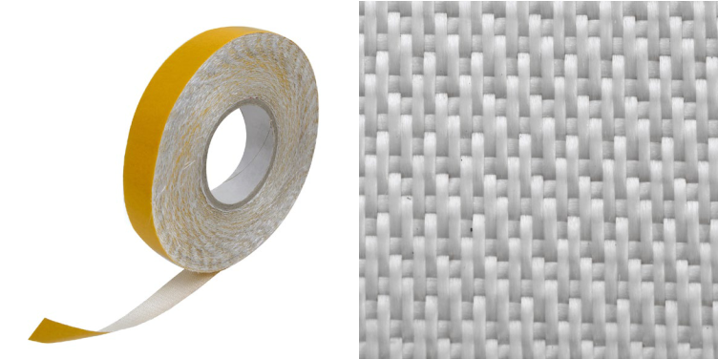

Use: joining insulation materials either glass fibre coated or not. It is characterised of resistance on occurrence the high temperatures up to 450°C.

Availability: in stock

PRODUCT CHARACTERISTICS

 |  | Finish | glass fibre
 |  | Thickness | 0,37mm +/- 0,02
 |  | Resistance to temperature | from +450°C
 |  | Application temperature | from +5°C to +30°C
 |  | Ultimate tensile strength | 5500 N/5cm; EN ISO 13934.1
 |  | Fire resistance | non flammable
 |  | Shelf life/storage | in temperature range from +10°C to +35°C
 |  |  | and relative humidity 40% do 70%

NAME

Glass fibre tape 420g/m2 30mm x 100mb

Glass fibre tape 420g/m2 50mm x 100mb

Glass fibre tape 420g/m2 75mm x 50mb

Glass fibre tape 420g/m2 75mm x 100mb

INDEX

T-01-007

T-01-008

T-01-009

T-01-010

ADDITIONAL Available also in self-adhesive version.

^{INFORMATION} Surfaces to be bonded must be clean, dry and free from dust, grease and loose materials. If necessary, wipe surfaces sparingly with a cloth dampened with a ketone-free cleaner and allow to dry for at least an hour before tape application.

TAPES | FABRICS | INSULATION | INSULATION | FASTENING | SD STUDS CABLE TRAYS OTHERS
 |  | FASTENERS | MATTRESSES | TECHNIQUES

GLASS FIBRE TAPE ST 1 GLASS FIBRE TAPE ST 55

Material: glass fibre, density 200g/m2
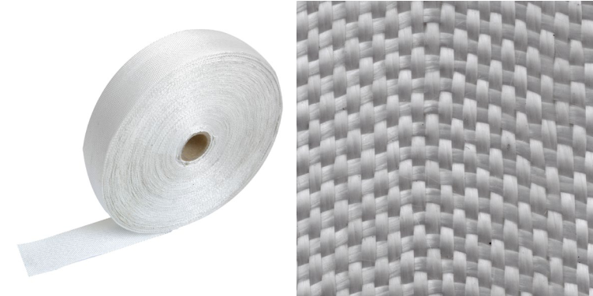

Use: fixing and packaging, assembly and repair, electrical insulation, insulation and protection. It has moisture resistance, easily laid to the ground. It has a MED certificate.

Availability: in stock

PRODUCT CHARACTERISTICS

 |  | Finish | glass fibre
 |  | Thickness | 0,20mm +/- 0,02
 |  | Resistance to temperature | from +450°C
 |  | Application temperature | from +5°C to +30°C
 |  | Ultimate tensile strength | 3000 N/5cm; EN ISO 13934.1
 |  | Fire resistance | non flammable
 |  | Shelf life/storage | in temperature range from +10°C to +35°C
 |  |  | and relative humidity 40% do 70%

NAME

Glass fibre tape 200g/m2 30mm x 100mb

Glass fibre tape 200g/m2 50mm x 100mb

Glass fibre tape 200g/m2 75mm x 50mb

Glass fibre tape 200g/m2 75mm x 100mb

INDEX

T-01-011

T-01-012

T-01-013

T-01-014

ADDITIONAL Surfaces to be bonded must be clean, dry and free from dust, grease and loose materials. INFORMATION If necessary, wipe surfaces sparingly with a cloth dampened with a ketone-free cleaner and

allow to dry for at least an hour before tape application.

7

TAPES | FABRICS | INSULATION | INSULATION | FASTENING | SD STUDS CABLE TRAYS OTHERS
 |  | FASTENERS | MATTRESSES | TECHNIQUES

DUCT TAPE

Material: fabric coated PE

U
Se

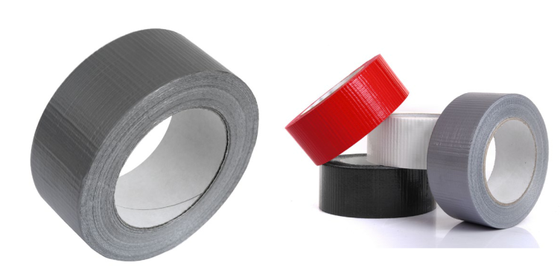
: mounting and packaging, assembly and repair, electrical insulation and protection. The tape with the resistance to moisture and easy apply to the surface.

Availability

PRODUCT CHARACTERISTICS

 |  | Finish | fabric coated PE
 |  | Colour | grey, black, white
 |  | Thickness | 0,14mm
 |  | Adhesive | adhesive (PSA)
 |  | Release paper | none
 |  | Service temperature | from -10°C to +75°C
 |  | Application temperature | from +5°C to +30°C
 |  | Ultimate tensile strength | 35 N/cm
 |  | Peel adhesion to steel | 4 N/cm; IEC 454-2
 |  |  | 6 months from the date of manufacture when stored
 |  | Shelf life/storage | within the temperature range +20°C and +30°C
 |  |  | and 50% RH

 | NAME |  |  |  | INDEX
 | Duct tape 50mm x 50mb |  |  |  | T-01-015

ADDITIONAL INFORMATION

TAPES | FABRICS | INSULATION | INSULATION | FASTENING | SD STUDS CABLE TRAYS OTHERS
 |  | FASTENERS | MATTRESSES | TECHNIQUES

RUBBER TAPE

Material: rubber foam
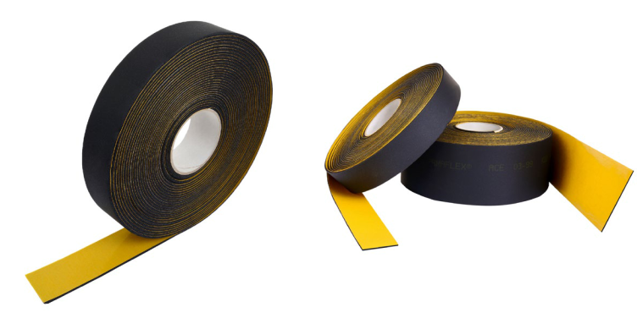

Use: adhesive tape used for assembly join in insulation made of synthetic rubber. The rubber tape is an insulation, sealing, suppressed and damping material. Prevents water vapor condensation and reduces energy losses.

Availability: in stock

PRODUCT CHARACTERISTICS

 |  | Finish | rubber foam
 |  | Thickness | 3mm
 |  | Adhesive | modified acrylic
 |  | Release paper | siliconised paper
 |  | Service temperature | from -20°C to +85°C
 |  | Peel adhesion | 22 N/25mm; AFERA 4001
 |  | Coefficient of resistance | >=7000; EN13469, EN12086
 |  | to water vapor diffusion
 |  | Coefficient of thermal conductivity | <=0,035 W/(m K) in average temp. 0°C
 |  | Coefficient of thermal conductivity | <=0,039 W/(m K) in average temp. 40°C
 |  | Reaction to fire | no spread of fire
 |  |  | 12 months from date of manufacture when stored
 |  | Shelf life/storage | within the temperature range 0°C and +35°C
 |  |  | and from 50% to 70% RH

 | NAME |  |  |  | INDEX
 | Rubber tape 50mm x 15mb |  |  |  | T-01-016

ADDITIONAL Surfaces to be bonded must be clean, dry and free from dust, grease and loose materials. INFORMATION If necessary, wipe surfaces sparingly with a cloth dampened with a ketone-free cleaner and

allow to dry for at least an hour before tape application.

9

TAPES | FABRICS | INSULATION | INSULATION | FASTENING | SD STUDS CABLE TRAYS OTHERS
 |  | FASTENERS | MATTRESSES | TECHNIQUES

CERAMIC TAPE (ADHESIVE)

Material: glass fibre
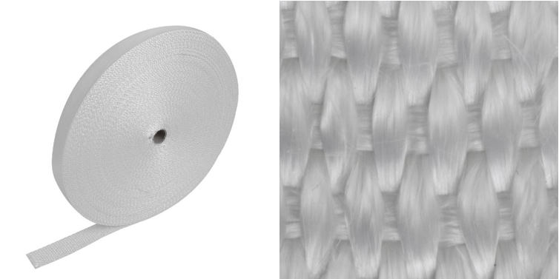

Use: thermal insulation high temperature installation, steam installation, hoses, cables, pipe connections, insulation of components exposed to high temperature. Tape made of non-combustible textile materials resistant on oils, fats, solvents, organic and non-organic acid. Constant running ability of temp. 550°C.

Availability: in stock

PRODUCT CHARACTERISTICS

 |  | Finish | glass fibre
 |  | Thickness | 3mm
 |  | Classification temperature | 550°C
 |  | Softening temperature | 840°C
 |  | Ultimate tensile strength | 2400 N/mm2
 |  | Modulus of elasticity | 73 GPa
 |  | Elongation | 3,3%
 |  | Coefficient of thermal expansion | 5 x 10-6K-1
 |  | Thermal conductivity | 0,04-0,06 W/mK
 |  | Dielectric constant | 6,1-6,7 ε
 |  | Fire resistance | non flammable
 |  | Shelf life/storage | 12 months from date of manufacture when stored within
 |  |  | the dry place with the temperature range +10°C and +30°

 | NAME |  |  |  | INDEX
 | Ceramic tape 30mm x 50mb |  |  |  | T-01-017

ADDITIONAL INFORMATION

10

TAPE FABRICS

INSULATION | INSULATION | FASTENING | SD STUDS CABLE TRAYS OTHERS
FASTENERS | MATTRESSES | TECHNIQUES

GLASS FABRIC ST 1 / T

 |  |  |  |  |  | Material: glass fibre
 |  |  |  |  |  | Use: thermal and electrical insulation material,
 |  |  |  |  |  | non-combustible, chemically neutral, absorbing
 |  |  |  |  |  | water in minimum quantities and practically
 |  |  |  |  |  | not subject to corrosion of water. It is resistant
 |  |  |  |  |  | to mould, rotting and breakdown strength. It is
 |  |  |  |  |  | certified by DNV. It is characterised of resistance
 |  |  |  |  |  | on occurrence the high temperatures up to
 |  |  |  |  |  | 450°C .
 |  |  |  |  |  | Availability: in stock
 |  | PRODUCT CHARACTERISTICS
 |  | Finish | glass fibre
 |  | Thickness | 0,37mm +/-0,02
 |  | Weight | 420 g/m2 +/-20
 |  | Width | 100cm +/-2
 |  | Resistance to temperature | to +450°C
 |  | Tensile strength warp | 5500 N/5cm
 |  | Type of treatment | raw
 |  | Fire resistance | non flammable
 |  | Shelf life/storage | within the temperature range +10°C and +35°C
 |  |  | and from 40% to 70% RH
 |  | NAME |  |  |  |  | INDEX
 |  | Glass fibre fabric ST1/T |  |  |  |  | T-02-420
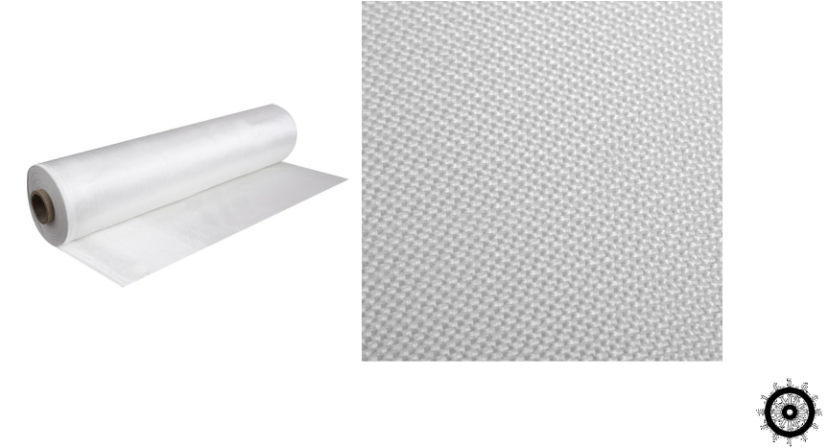

ADDITIONAL The standard width of the fabric is 1m. Current information on other roll widths is available

INFORMATION on request.

11

TAPE FABRICS

INSULATION | INSULATION | FASTENING | SD STUDS CABLE TRAYS OTHERS
FASTENERS | MATTRESSES | TECHNIQUES

GLASS FABRIC ST 1 / T ALU

Material: glass fibre, aluminium coated
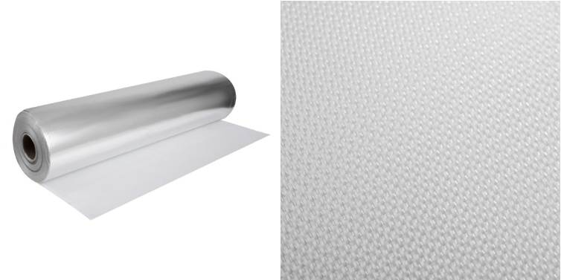

Use: thermal and electrical insulation material, non flammable, chemically neutral, hardly absorbing water and water corrosion resistant. It is resistant to mould, rotting and breakdown strength. It is characterised by high temperature resistance up to 450°C.

Availability: in stock

PRODUCT CHARACTERISTICS

 |  | Finish | glass fibre
 |  | Thickness | 0,37mm +/-0,02
 |  | Weight | 420 g/m2 +/-8
 |  | Width | 100cm +/-2
 |  | Resistance to temperature | to +450°C
 |  | Tensile strength warp | 5500 N/5cm
 |  | Type of treatment | raw
 |  | Coating | aluminium
 |  | Fire resistance | non flammable
 |  | Shelf life/storage | within the temperature range +10°C and +35°C
 |  |  | and from 40% to 70% RH

 | NAME |  |  |  | INDEX
 | Glass fibre fabric ST1/T ALU |  |  |  | T-02-420A

INSULA TION TECHNIQU

TAPE FABRICS

INSULATION | INSULATION | FASTENING | SD STUDS CABLE TRAYS OTHERS
FASTENERS | MATTRESSES | TECHNIQUES

GLASS FABRIC ST 55 / T

Material: glass fibre
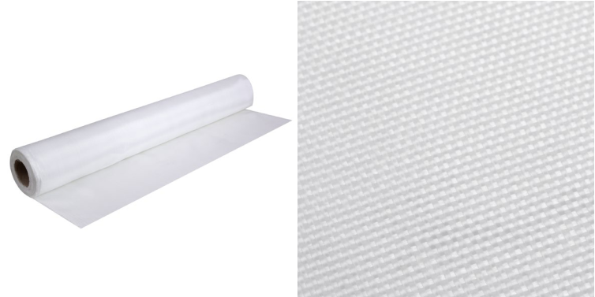

Use: thermal and electrical insulation material, non flammable, chemically neutral, hardly absorbing water and water corrosion resistant. It is resistant to mould, rotting and breakdown strength. It is certified by DNV. It is characterised by high temperature resistance up to 450°C.

Availability: in stock

PRODUCT CHARACTERISTICS

 |  | Finish | glass fibre
 |  | Thickness | 0,20mm +/-0,02
 |  | Weight | 200 g/m2 +/-8
 |  | Width | 100cm +/-2
 |  | Resistance to temperature | to +450°C
 |  | Tensile strength warp | 3000 N/5cm
 |  | Type of treatment | raw
 |  | Fire resistance | non flammable
 |  | Shelf life/storage | within the temperature range +10°C and +35°C
 |  |  | and from 40% to 70% RH

 | NAME |  |  |  | INDEX
 | Glass fibre fabric ST55/T |  |  |  | T-02-200

ADDITIONAL The standard width of the fabric is 1m. Current information on other roll widths is available INFORMATION on request.

13

TAPE FABRICS

INSULATION | INSULATION | FASTENING | SD STUDS CABLE TRAYS OTHERS
FASTENERS | MATTRESSES | TECHNIQUES

GLASS FABRIC ST 55 / T ALU

Material: glass fibre, aluminium coated
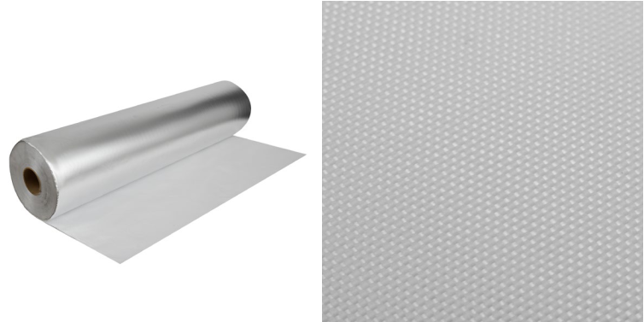

Use: thermal and electrical insulation material, non flammable, chemically neutral, hardly absorbing water and water corrosion resistant. It is resistant to mould, rotting and breakdown strength. It is characterised by high temperature resistance up to 450°C.

Availability: in stock

PRODUCT CHARACTERISTICS

 |  | Finish | glass fibre
 |  | Thickness | 0,20mm +/-0,02
 |  | Weight | 200 g/m2 +/-8
 |  | Width | 100cm +/-2
 |  | Resistance to temperature | to +450°C
 |  | Tensile strength warp | 3000 N/5cm
 |  | Type of treatment | raw
 |  | Coating | aluminium
 |  | Fire resistance | non flammable
 |  | Shelf life/storage | within the temperature range +10°C and +35°C
 |  |  | and from 40% to 70% RH

 | NAME |  |  |  | INDEX
 | Glass fibre fabric ST55/T ALU |  |  |  | T-02-200A

INSULA TION

TAPE FABRICS

INSULATION | INSULATION | FASTENING | SD STUDS CABLE TRAYS OTHERS
FASTENERS | MATTRESSES | TECHNIQUES

GLASS FABRIC SILICONED (1 SIDE)
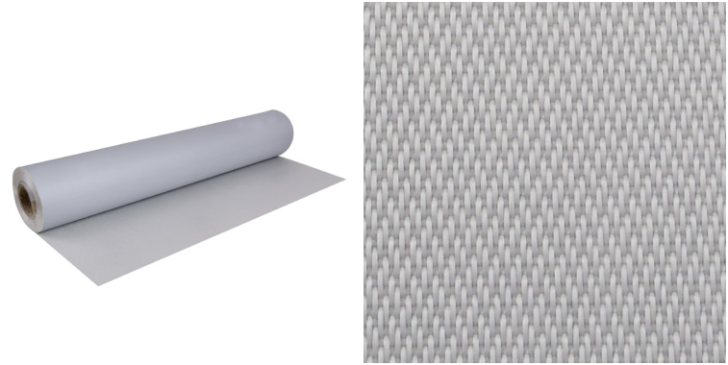

Material: glass fibre, one-sided silicone coating (1 side silicone coated glass fabric)

Use: resistant on oils, fats, solvents, organic and non-organic acid. The high immunity on mechanical, thermo and electrical failures, UV, water resistant. Characterised by good electric insulation properties.

Availability: in stock

PRODUCT CHARACTERISTICS

 |  | Finish | glass fibre
 |  | Thickness | 0,5mm
 |  | Weight | 430 g/m2
 |  | Width | 100cm
 |  | Service temperature | from -50°C to +250°C
 |  | Tensile strength warp | 3800 N/50mm
 |  | Coating | silicone
 |  | Fire resistance | non flammable
 |  | Shelf life/storage | within the temperature range +10°C and +35°C
 |  |  | and from 40% to 70% RH

 | NAME |  |  |  | INDEX
 | Silicone fabric on one side with glass fibre |  |  |  | T-02-430S1

1

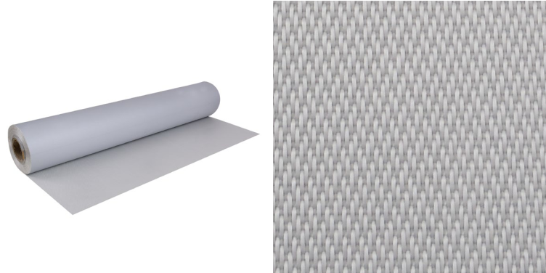

GLASS FABRIC SILICONED (2 SIDES)

Material: glass fibre, double-sided silic

Use:

 |  | Finish | glass fibre
 |  | Thickness | 0,5mm
 |  | Weight | 430 g/m2
 |  | Width | 100cm
 |  | Service temperature | from -50°C to +250°C
 |  | Tensile strength warp | 3800 N/50mm
 |  | Coating | silicone
 |  | Fire resistance | non flammable
 |  | Shelf life/storage | within the temperature range +10°C and +35°C
 |  |  | and from 40% to 70% RH

 | NAME |  |  |  | INDEX
 | Silicone fabric on two sides with glass fibre |  |  |  | T-02-430S2

FASTENERS | MATTRESSES | TECHNIQUES

GLASS FABRIC PASTED
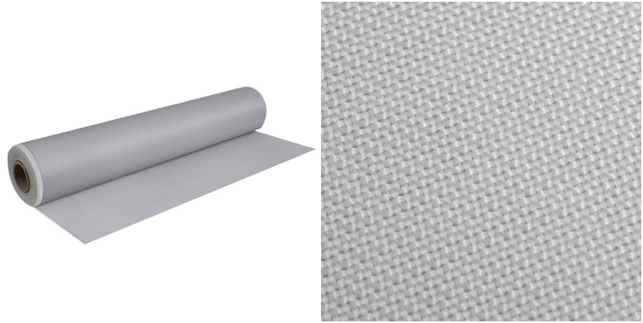

Material: glass fibre

Use: material with excellent insulating properties, characterised by resistant for wear and tear.

Availability: in stock

PRODUCT CHARACTERISTICS

 |  | Finish | glass fibre
 |  | Thickness | 0,18mm
 |  | Weight | 220 g/m2 +/- 5%
 |  | Width | 100cm
 |  | Service temperature | 300-400°C
 |  | Tensile strength warp | 470 N/cm
 |  | Coating | pasted 20g/m2
 |  | Fire resistance | non flammable
 |  | Shelf life/storage | within the temperature range +10°C and +35°C
 |  |  | and from 40% to 70% RH

 | NAME |  |  |  | INDEX
 | Glass fibre fabric pasted |  |  |  | T-02-220P

17

INSULATION
TAPES FABRICS _{FASTENERS}

INSULATION | FASTENING | SD STUDS CABLE TRAYS OTHERS
MATTRESSES | TECHNIQUES

INSULATION PIN

Material: copper covered steel, stainless steel 1.4301
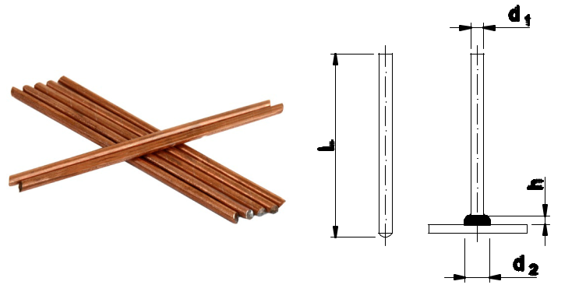

Use: assembling the insulation in the marine and land industry. Insulation pins are made of heat-sealable wire in diameters range Ø2mm to Ø5mm.

Availability: on request

Logistic minimum:

25mm – 50mm – 2000 pcs./package

60mm – 150mm – 1000 pcs./package

from 160mm – 500 pcs./package

MATERIAL: COPPER COVERED STEEL

 |  | d₁ | L | d₂≈ | h≈ | Weight (kg/100) | Index
 | 2 |  | 25 | 6,0 | 3,5 | 0,062 | T-03-012025
 | 2 |  | 30 | 6,0 | 3,5 | 0,075 | T-03-012030
 | 2 |  | 40 | 6,0 | 3,5 | 0,100 | T-03-012040
 | 2 |  | 50 | 6,0 | 3,5 | 0,125 | T-03-012050
 | 2 |  | 60 | 6,0 | 3,5 | 0,150 | T-03-012060
 | 2 |  | 65 | 6,0 | 3,5 | 0,162 | T-03-012065
 | 2 |  | 70 | 6,0 | 3,5 | 0,175 | T-03-012070
 | 2 |  | 80 | 6,0 | 3,5 | 0,200 | T-03-012080
 | 2 |  | 85 | 6,0 | 3,5 | 0,213 | T-03-012085
 | 2 |  | 90 | 6,0 | 3,5 | 0,225 | T-03-012090
 | 2 |  | 100 | 6,0 | 3,5 | 0,250 | T-03-012100
 | 2 |  | 110 | 6,0 | 3,5 | 0,275 | T-03-012110
 | 2 |  | 120 | 6,0 | 3,5 | 0,300 | T-03-012120
 | 2 |  | 130 | 6,0 | 3,5 | 0,325 | T-03-012130
 | 2 |  | 140 | 6,0 | 3,5 | 0,350 | T-03-012140
 | 2 |  | 160 | 6,0 | 3,5 | 0,401 | T-03-012160
 | 2 |  | 200 | 6,0 | 3,5 | 0,501 | T-03-012200
 | 3 |  | 25 | 6,0 | 3,5 | 0,148 | T-03-013025
 | 3 |  | 30 | 6,0 | 3,5 | 0,174 | T-03-013030
 | 3 |  | 40 | 6,0 | 3,5 | 0,234 | T-03-013040
 | 3 |  | 50 | 6,0 | 3,5 | 0,286 | T-03-013050
 | 3 |  | 60 | 6,0 | 3,5 | 0,340 | T-03-013060
 | 3 |  | 65 | 6,0 | 3,5 | 0,366 | T-03-013065
 | 3 |  | 70 | 6,0 | 3,5 | 0,398 | T-03-013070
 | 3 |  | 80 | 6,0 | 3,5 | 0,454 | T-03-013080
 | 3 |  | 85 | 6,0 | 3,5 | 0,480 | T-03-013085
 | 3 |  | 90 | 6,0 | 3,5 | 0,506 | T-03-013090
 | 3 |  | 100 | 6,0 | 3,5 | 0,564 | T-03-013100
 | 3 |  | 110 | 6,0 | 3,5 | 0,620 | T-03-013110
 | 3 |  | 120 | 6,0 | 3,5 | 0,673 | T-03-013120
 | 3 |  | 130 | 6,0 | 3,5 | 0,735 | T-03-013130
 | 3 |  | 140 | 6,0 | 3,5 | 0,784 | T-03-013140
 | 3 |  | 160 | 6,0 | 3,5 | 0,892 | T-03-013160
 | 3 |  | 200 | 6,0 | 3,5 | 1,108 | T-03-013200

INSULATION
TAPES FABRICS _{FASTENERS}

INSULATION | FASTENING | SD STUDS CABLE TRAYS OTHERS
MATTRESSES | TECHNIQUES

 |  | d₁ | L | d₂≈ | h≈ |  | Weight (kg/100) | Index
 | 4 |  | 25 | 6,0 | 3,5 |  | 0,265 | T-03-014025
 | 4 |  | 30 | 6,0 | 3,5 |  | 0,318 | T-03-014030
 | 4 |  | 40 | 6,0 | 3,5 |  | 0,424 | T-03-014040
 | 4 |  | 50 | 6,0 | 3,5 |  | 0,480 | T-03-014050
 | 4 |  | 60 | 6,0 | 3,5 |  | 0,664 | T-03-014060
 | 4 |  | 65 | 6,0 | 3,5 |  | 0,697 | T-03-014065
 | 4 |  | 70 | 6,0 | 3,5 |  | 0,730 | T-03-014070
 | 4 |  | 80 | 6,0 | 3,5 |  | 0,760 | T-03-014080
 | 4 |  | 85 | 6,0 | 3,5 |  | 0,901 | T-03-014085
 | 4 |  | 90 | 6,0 | 3,5 |  | 0,954 | T-03-014090
 | 4 |  | 100 | 6,0 | 3,5 |  | 0,980 | T-03-014100
 | 4 |  | 110 | 6,0 | 3,5 |  | 1,125 | T-03-014110
 | 4 |  | 120 | 6,0 | 3,5 |  | 1,270 | T-03-014120
 | 4 |  | 130 | 6,0 | 3,5 |  | 1,395 | T-03-014130
 | 4 |  | 140 | 6,0 | 3,5 |  | 1,411 | T-03-014140
 | 4 |  | 160 | 6,0 | 3,5 |  | 1,705 | T-03-014160
 | 4 |  | 200 | 6,0 | 3,5 |  | 2,020 | T-03-014200
 | 5 |  | 25 | 6,0 | 3,5 |  |  | T-03-015025
 | 5 |  | 30 | 6,0 | 3,5 |  |  | T-03-015030
 | 5 |  | 40 | 6,0 | 3,5 |  |  | T-03-015040
 | 5 |  | 50 | 6,0 | 3,5 |  |  | T-03-015050
 | 5 |  | 60 | 6,0 | 3,5 |  |  | T-03-015060
 | 5 |  | 70 | 6,0 | 3,5 |  |  | T-03-015070
 | 5 |  | 80 | 6,0 | 3,5 |  |  | T-03-015080
 | 5 |  | 90 | 6,0 | 3,5 |  |  | T-03-015090
 | 5 |  | 100 | 6,0 | 3,5 |  |  | T-03-015100
 | 5 |  | 110 | 6,0 | 3,5 |  |  | T-03-015110
 | 5 |  | 120 | 6,0 | 3,5 |  |  | T-03-015120
 | 5 |  | 130 | 6,0 | 3,5 |  |  | T-03-015130
 | 5 |  | 140 | 6,0 | 3,5 |  |  | T-03-015140
 | 5 |  | 150 | 6,0 | 3,5 |  |  | T-03-015150
 | 5 |  | 160 | 6,0 | 3,5 |  |  | T-03-015160
 | 5 |  | 200 | 6,0 | 3,5 |  |  | T-03-015200
 |  | MATERIAL: STAINLESS STEEL 1.4301
 |  | d₁ | L | d₂≈ | h≈ |  | Weight (kg/100) | Index
 | 3 |  | 25 | 6,0 | 3,5 |  | 0,148 | T-03-023025
 | 3 |  | 30 | 6,0 | 3,5 |  | 0,174 | T-03-023030
 | 3 |  | 40 | 6,0 | 3,5 |  | 0,234 | T-03-023040
 | 3 |  | 50 | 6,0 | 3,5 |  | 0,286 | T-03-023050
 | 3 |  | 60 | 6,0 | 3,5 |  | 0,340 | T-03-023060
 | 3 |  | 70 | 6,0 | 3,5 |  | 0,398 | T-03-023070
 | 3 |  | 80 | 6,0 | 3,5 |  | 0,454 | T-03-023080
 | 3 |  | 90 | 6,0 | 3,5 |  | 0,506 | T-03-023090
 | 3 |  | 100 | 6,0 | 3,5 |  | 0,564 | T-03-023100
 | 3 |  | 110 | 6,0 | 3,5 |  | 0,620 | T-03-023110
 | 3 |  | 120 | 6,0 | 3,5 |  | 0,610 | T-03-023120
 | 3 |  | 130 | 6,0 | 3,5 |  | 0,735 | T-03-023130
 | 3 |  | 140 | 6,0 | 3,5 |  | 0,784 | T-03-023140
 | 3 |  | 150 | 6,0 | 3,5 |  | 0,840 | T-03-023150
 | 3 |  | 160 | 6,0 | 3,5 |  | 0,892 | T-03-023160
 | 3 |  | 200 | 6,0 | 3,5 |  | 1,108 | T-03-023200
ADDITIONAL |  |  | Other dimensions and materials are available on request, eg. stainless steel 1.4571, IS 4
INFORMATION |  |  | and IS 5 in material 1.4031.

19

INSULATION
TAPES FABRICS _{FASTENERS}

INSULATION | FASTENING | SD STUDS CABLE TRAYS OTHERS
MATTRESSES | TECHNIQUES

BIMETAL PIN VBS (ALUMINIUM AREA)

 |  |  |  |  |  |  |  |  |  |  |  |  |  |  |  |  |  |  |  |  |  |  |  |  |  |  |  |  |  |  |  |  | Material: copper covered steel, stainless steel 1.4301
 |  |  |  |  |  |  |  |  |  |  |  |  |  |  |  |  |  |  |  |  |  |  |  |  |  |  |  |  |  |  |  |  | (aluminium ending)
 |  |  |  |  |  |  |  |  |  |  |  |  |  |  |  |  |  |  |  |  |  |  |  |  |  |  |  |  |  |  |  |  | Use: assembling the insulation on aluminium
 |  |  |  |  |  |  |  |  |  |  |  |  |  |  |  |  |  |  |  |  |  |  |  |  |  |  |  |  |  |  |  |  | surfaces in the marine and land industry. Bimetal pins
 |  |  |  |  |  |  |  |  |  |  |  |  |  |  |  |  |  |  |  |  |  |  |  |  |  |  |  |  |  |  |  |  | are made of heat-sealable wire in diameter ø3mm.
 |  |  |  |  |  |  |  |  |  |  |  |  |  |  |  |  |  |  |  |  |  |  |  |  |  |  |  |  |  |  |  |  | Availability: on request
 |  |  |  |  |  |  |  |  |  |  |  |  |  |  |  |  |  |  |  |  |  |  |  |  |  |  |  |  |  |  |  |  | Logistic minimum:
 |  |  |  |  |  |  |  |  |  |  |  |  |  |  |  |  |  |  |  |  |  |  |  |  |  |  |  |  |  |  |  |  | 25mm – 40mm – 2000 pcs./package
 |  |  |  |  |  |  |  |  |  |  |  |  |  |  |  |  |  |  |  |  |  |  |  |  |  |  |  |  |  |  |  |  | 50mm – 100mm – 1000 pcs./package
 |  |  |  |  |  |  |  |  |  |  |  |  |  |  |  |  |  |  |  |  |  |  |  |  |  |  |  |  |  |  |  |  | from 110mm – 500 pcs./package
 |  | MATERIAL: COPPER COVERED STEEL
 |  | ^{d}1 | L |  |  |  |  |  |  |  | d₂≈ |  |  |  |  |  |  |  |  |  |  |  |  |  |  |  | h≈ |  |  |  |  |  | ^{d}3 | Weight (kg/100) | Index
 |  | 3 | 25 | 7,8 |  |  |  |  |  |  |  |  |  |  |  |  |  |  |  |  |  |  |  |  | 16 |  |  |  |  |  |  | 6 |  | 0,148 | T-03-113025
 |  | 3 | 30 | 7,8 |  |  |  |  |  |  |  |  |  |  |  |  |  |  |  |  |  |  |  |  | 16 |  |  |  |  |  |  | 6 |  | 0,174 | T-03-113030
 |  | 3 | 40 | 7,8 |  |  |  |  |  |  |  |  |  |  |  |  |  |  |  |  |  |  |  |  | 16 |  |  |  |  |  |  | 6 |  | 0,234 | T-03-113040
 |  | 3 | 50 | 7,8 |  |  |  |  |  |  |  |  |  |  |  |  |  |  |  |  |  |  |  |  | 16 |  |  |  |  |  |  | 6 |  | 0,286 | T-03-113050
 |  | 3 | 60 | 7,8 |  |  |  |  |  |  |  |  |  |  |  |  |  |  |  |  |  |  |  |  | 16 |  |  |  |  |  |  | 6 |  | 0,340 | T-03-113060
 |  | 3 | 65 | 7,8 |  |  |  |  |  |  |  |  |  |  |  |  |  |  |  |  |  |  |  |  | 16 |  |  |  |  |  |  | 6 |  | 0,366 | T-03-113065
 |  | 3 | 70 | 7,8 |  |  |  |  |  |  |  |  |  |  |  |  |  |  |  |  |  |  |  |  | 16 |  |  |  |  |  |  | 6 |  | 0,398 | T-03-113070
 |  | 3 | 80 | 7,8 |  |  |  |  |  |  |  |  |  |  |  |  |  |  |  |  |  |  |  |  | 16 |  |  |  |  |  |  | 6 |  | 0,454 | T-03-113080
 |  | 3 | 85 | 7,8 |  |  |  |  |  |  |  |  |  |  |  |  |  |  |  |  |  |  |  |  | 16 |  |  |  |  |  |  | 6 |  | 0,480 | T-03-113085
 |  | 3 | 90 | 7,8 |  |  |  |  |  |  |  |  |  |  |  |  |  |  |  |  |  |  |  |  | 16 |  |  |  |  |  |  | 6 |  | 0,506 | T-03-113090
 |  | 3 | 100 | 7,8 |  |  |  |  |  |  |  |  |  |  |  |  |  |  |  |  |  |  |  |  | 16 |  |  |  |  |  |  | 6 |  | 0,564 | T-03-113100
 |  | 3 | 110 | 7,8 |  |  |  |  |  |  |  |  |  |  |  |  |  |  |  |  |  |  |  |  | 16 |  |  |  |  |  |  | 6 |  | 0,620 | T-03-113110
 |  | 3 | 120 | 7,8 |  |  |  |  |  |  |  |  |  |  |  |  |  |  |  |  |  |  |  |  | 16 |  |  |  |  |  |  | 6 |  | 0,673 | T-03-113120
 |  | 3 | 130 | 7,8 |  |  |  |  |  |  |  |  |  |  |  |  |  |  |  |  |  |  |  |  | 16 |  |  |  |  |  |  | 6 |  | 0,735 | T-03-113130
 |  | 3 | 140 | 7,8 |  |  |  |  |  |  |  |  |  |  |  |  |  |  |  |  |  |  |  |  | 16 |  |  |  |  |  |  | 6 |  | 0,784 | T-03-113140
 |  | 3 | 160 | 7,8 |  |  |  |  |  |  |  |  |  |  |  |  |  |  |  |  |  |  |  |  | 16 |  |  |  |  |  |  | 6 |  | 0,892 | T-03-113160
 | 3 |  | 200 | 7,8 |  |  |  |  |  |  |  |  |  |  |  |  |  |  |  |  |  |  |  |  | 16 |  |  |  |  |  |  | 6 |  | 1,108 | T-03-113200
 |  | MATERIAL: STAINLESS STEEL 1.4301
 |  | d₁ | L |  |  |  |  |  |  |  | d₂≈ |  |  |  |  |  |  |  |  |  |  |  |  |  |  |  | h≈ |  |  |  |  |  | d₃ | Weight (kg/100) | Index
 |  | 3 | 25 | 7,8 |  |  |  |  |  |  |  |  |  |  |  |  |  |  |  |  |  |  |  |  | 16 |  |  |  |  |  |  | 6 |  | 0,148 | T-03-123025
 |  | 3 | 30 | 7,8 |  |  |  |  |  |  |  |  |  |  |  |  |  |  |  |  |  |  |  |  | 16 |  |  |  |  |  |  | 6 |  | 0,174 | T-03-123030
 |  | 3 | 40 | 7,8 |  |  |  |  |  |  |  |  |  |  |  |  |  |  |  |  |  |  |  |  | 16 |  |  |  |  |  |  | 6 |  | 0,234 | T-03-123040
 |  | 3 | 50 | 7,8 |  |  |  |  |  |  |  |  |  |  |  |  |  |  |  |  |  |  |  |  | 16 |  |  |  |  |  |  | 6 |  | 0,286 | T-03-123050
 |  | 3 | 60 | 7,8 |  |  |  |  |  |  |  |  |  |  |  |  |  |  |  |  |  |  |  |  | 16 |  |  |  |  |  |  | 6 |  | 0,340 | T-03-123060
 |  | 3 | 70 | 7,8 |  |  |  |  |  |  |  |  |  |  |  |  |  |  |  |  |  |  |  |  | 16 |  |  |  |  |  |  | 6 |  | 0,398 | T-03-123070
 |  | 3 | 80 | 7,8 |  |  |  |  |  |  |  |  |  |  |  |  |  |  |  |  |  |  |  |  | 16 |  |  |  |  |  |  | 6 |  | 0,454 | T-03-123080
 |  | 3 | 90 | 7,8 |  |  |  |  |  |  |  |  |  |  |  |  |  |  |  |  |  |  |  |  | 16 |  |  |  |  |  |  | 6 |  | 0,506 | T-03-123090
 |  | 3 | 100 | 7,8 |  |  |  |  |  |  |  |  |  |  |  |  |  |  |  |  |  |  |  |  | 16 |  |  |  |  |  |  | 6 |  | 0,564 | T-03-123100
 |  | 3 | 110 | 7,8 |  |  |  |  |  |  |  |  |  |  |  |  |  |  |  |  |  |  |  |  | 16 |  |  |  |  |  |  | 6 |  | 0,620 | T-03-123110
 |  | 3 | 120 | 7,8 |  |  |  |  |  |  |  |  |  |  |  |  |  |  |  |  |  |  |  |  | 16 |  |  |  |  |  |  | 6 |  | 0,610 | T-03-123120
 |  | 3 | 130 | 7,8 |  |  |  |  |  |  |  |  |  |  |  |  |  |  |  |  |  |  |  |  | 16 |  |  |  |  |  |  | 6 |  | 0,735 | T-03-123130
 |  | 3 | 140 | 7,8 |  |  |  |  |  |  |  |  |  |  |  |  |  |  |  |  |  |  |  |  | 16 |  |  |  |  |  |  | 6 |  | 0,784 | T-03-123140
 |  | 3 | 150 | 7,8 |  |  |  |  |  |  |  |  |  |  |  |  |  |  |  |  |  |  |  |  | 16 |  |  |  |  |  |  | 6 |  | 0,840 | T-03-123150
 |  | 3 | 160 | 7,8 |  |  |  |  |  |  |  |  |  |  |  |  |  |  |  |  |  |  |  |  | 16 |  |  |  |  |  |  | 6 |  | 0,892 | T-03-123160
 | 3 |  | 200 | 7,8 |  |  |  |  |  |  |  |  |  |  |  |  |  |  |  |  |  |  |  |  | 16 |  |  |  |  |  |  | 6 |  | 1,108 | T-03-123200
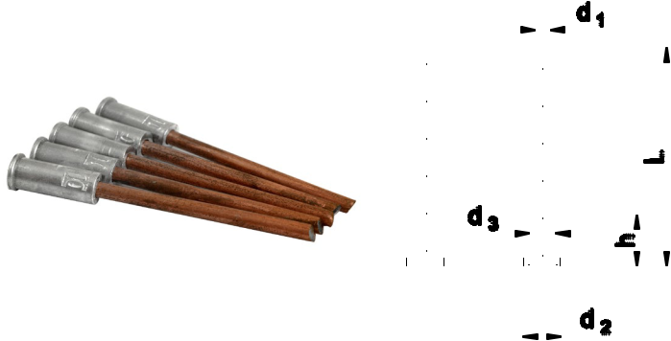

INSULATION
TAPES FABRICS _{FASTENERS}

INSULATION | FASTENING | SD STUDS CABLE TRAYS OTHERS
MATTRESSES | TECHNIQUES

PIN WITH SELF-ADHESIVE HOLDER

 | Material: copper covered steel, stainless steel 1.4301,
 | holder stainless steel or galvanized
 | Use: assembling the insulation on surfaces where
 | it is impossible to heat seal the pins (eg. too thin
 | metal plates). Insulation pins are made of heat-
 | sealable wire in diameters range Ø2mm to Ø5mm.
 | Holder sizes 5x5cm, self-adhesive.
 | Availability: on request
 | Logistic minimum:
 | 25mm – 100mm – 1000 pcs./package
 | from 110mm – 500 pcs./package
Name | ^{d}1 | p | p’ | h
Pin with self-adhesive stainless steel holder | ø2;3;4;5 | 50 | 50 | 0,5
Pin with self-adhesive galvanized holder | ø2;3;4;5 | 50 | 50 | 0,7
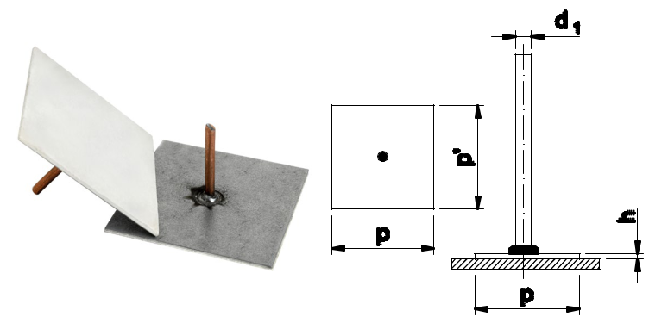

ADDITIONAL Available dimensions pins according to the dimensions of the heat-sealable insulating pins.

INFORMATION

21

INSULATION
TAPES FABRICS _{FASTENERS}

INSULATION | FASTENING | SD STUDS CABLE TRAYS OTHERS
MATTRESSES | TECHNIQUES

PIN WITH PERFORATED HOLDER

Material: copper covered steel, stainless steel 1.4301, holder galvanized
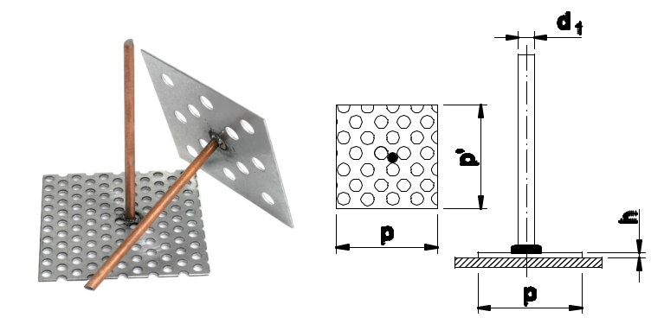

Use: assembling the insulation on surfaces where it is impossible to heat seal the pins (eg. too thin metal plates). Insulation pins are made of heat-sealable wire in diameters range Ø2mm to Ø5mm. Holder sizes 5x5cm, assembled using a glue type Sikaflex.

Availability: on request

Logistic minimum:

25mm – 100mm – 1000 pcs./package

from 110mm – 500 pcs./package

 |  | Name | d₁ | Minimum logistyczne: |  | h
 |  |  |  | p | p’
 |  | Pin with perforated galvanized holder | ø2;3;4;5 | 25mm – 100mm – 1000 szt. /op. od 110mm |  |  | –
 |  |  |  | 50 | 50 | 0,7
 |  |  |  | 500 szt. /op.

ADDITIONAL INFORMATION

22

INSULATION | FASTENING | SD STUDS CABLE TRAYS OTHERS
MATTRESSES | TECHNIQUES

PIN WITH SCREW

Material: copper covered steel, stainless steel 1.4301,
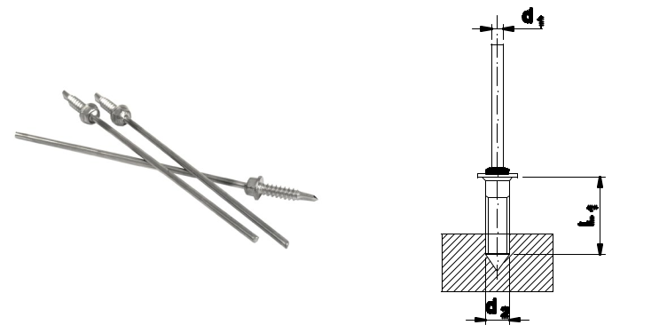

screw galvanized, stainless steel

Use: supplied with screw in any dimension. Tools are available to purchase to match the screws used. Insulation pins are made of heat-sealable wire in diameters range Ø2mm to Ø5mm.

Availability: on request

Logistic minimum:

25mm – 40mm – 2000 pcs./package

50mm – 100mm – 1000 pcs./package

from 110mm – 500 pcs./package

 |  | Name | d₁ | d₂ | L₁
 |  | Pin with screw | ø2;3;4;5 | any size | any size
ADDITIONAL |  |  | Available dimensions pins according to the dimensions of the heat-sealable insulating pins.
INFORMATION

THE ORDERING PROCEDURE FOR PINS

The pins with self-adhesive holders, perforated holders and screw are available in any dimension similar to heat seal insulating pins.

When ordering the above pins the assigned index to the insulation pin should be used (page no 18). At the end of index specific symbol should be used according to the below table:

 |  |  | self-adhesive |  | perforated |  | with screw
 |  | Steel | copper | stainless | copper | stainless | copper | stainless
 |  |  | covered | 1.4301 | covered | 1.4301 | covered | 1.4301
 | Holder | stainless | -SMN | -SNN | - | - | - | -
 |  | galvanized | -SMO | -SNO | -PM | -PN | - | -
 |  | with screw | - | - | - | - | -WM | -WN

ADDITIONAL For example: Pin with self-adhesive holder, 3 x 40mm, copper covered steel, holder stainless steel INFORMATION – [T-03-013040 - SMN]

23

INSULATION
TAPES FABRICS _{FASTENERS}

INSULATION | FASTENING | SD STUDS CABLE TRAYS OTHERS
MATTRESSES | TECHNIQUES

CLIP TYPE R

Material: galvanized steel ST, OC; stainless
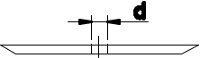

steel 1.4301
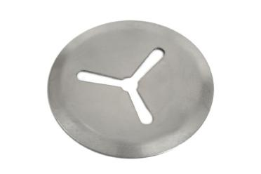

Use: applicable for mounting insulation on all types of pins.
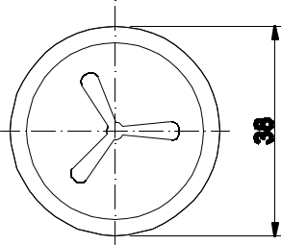

Availability: in stock

Logistic minimum: 6000 pcs./package

MATERIAL: STEEL ST

 |  | d | Diameter (mm) | Weight (kg/100) | Index
 | 3 |  | 38 | 0,35 | T-03-001
 | 4 |  | 38 | 0,35 | T-03-002
 | 5 |  | 38 | 0,35 | T-03-003

MATERIAL: STEEL OC

 |  | d | Diameter (mm) | Weight (kg/100) | Index
 | 3 |  | 38 | 0,35 | T-03-004
 | 4 |  | 38 | 0,35 | T-03-005
 | 5 |  | 38 | 0,35 | T-03-006

MATERIAL: STAINLESS STEEL 1.4301

 |  | d | Diameter (mm) | Weight (kg/100) | Index
 | 3 |  | 38 | 0,35 | T-03-007
 | 4 |  | 38 | 0,35 | T-03-008
 | 5 |  | 38 | 0,35 | T-03-009

24

INSULATION
TAPES FABRICS _{FASTENERS}

INSULATION | FASTENING | SD STUDS CABLE TRAYS OTHERS
MATTRESSES | TECHNIQUES

CLIP TYPE WN (DECORATIVE)

Material: galvanized steel ST, OC; stainless steel 1.4301
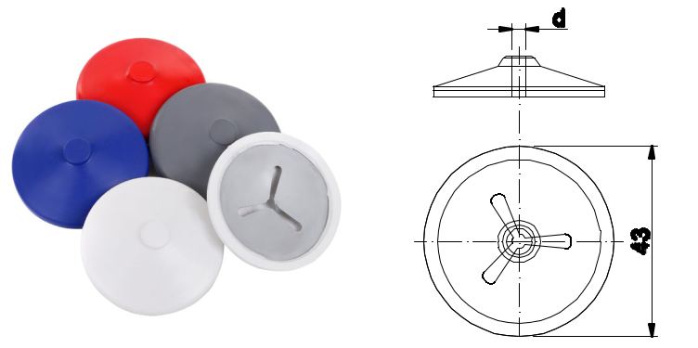

Use: applicable for mounting insulation on all types of pins. Clip supplied with decorative PVC cover.

Availability: in stock

Logistic minimum: 2500 pcs./package

MATERIAL: STEEL ST

 |  | d | Diameter (mm) | Weight (kg/100) | Index
 | 3 |  | 43 | 0,35 | T-03-010
 | 4 |  | 43 | 0,35 | T-03-011
 | 5 |  | 43 | 0,35 | T-03-012

MATERIAL: STEEL OC

 |  | d | Diameter (mm) | Weight (kg/100) | Index
 | 3 |  | 43 | 0,35 | T-03-013
 | 4 |  | 43 | 0,35 | T-03-014
 | 5 |  | 43 | 0,35 | T-03-015

MATERIAL: STAINLESS STEEL 1.4301

 |  | d | Diameter (mm) | Weight (kg/100) | Index
 | 3 |  | 43 | 0,35 | T-03-016
 | 4 |  | 43 | 0,35 | T-03-017
 | 5 |  | 43 | 0,35 | T-03-018

ADDITIONAL The standard cover of the clip is white.

^{INFORMATION} Other colours are available, eg. silver, black. Index available on request.

25

INSULATION
TAPES FABRICS _{FASTENERS}

INSULATION | FASTENING | SD STUDS CABLE TRAYS OTHERS
MATTRESSES | TECHNIQUES

CLIP TYPE R (WITH STRAP)

Material: galvanized steel ST
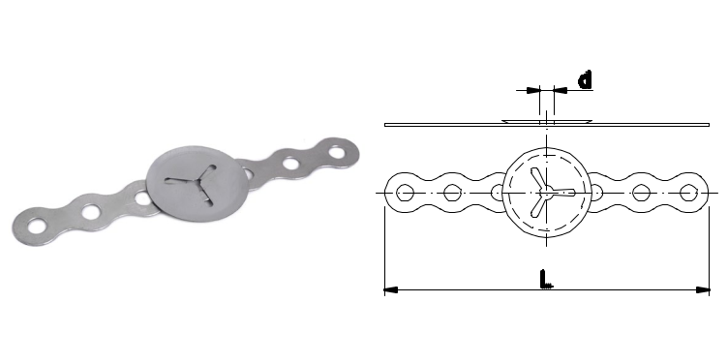

Use: the clip with additional strap; applied to hold the assembled electrical wires.

Availability: on request

Logistic minimum: 3000 pcs./package

MATERIAL: STEEL ST

 |  | d | Diameter (mm) | L | Weight (kg/100) | Index
 | 3 |  | 38 | 135 | 0,35 | T-03-019
 | 4 |  | 38 | 135 | 0,35 | T-03-020
 | 5 |  | 38 | 135 | 0,35 | T-03-021

ADDITIONAL INFORMATION

26

The standard width of the strap is 135mm. Current information on other roll widths is available on request.

TAPES | FABRICS | INSULATION | INSULATION | FASTENING | SD STUDS CABLE TRAYS OTHERS
 |  | FASTENERS | MATTRESSES | TECHNIQUES

THERMAL INSULATION MATTRESSES

Material: heat-resistant mineral wool and fabrics
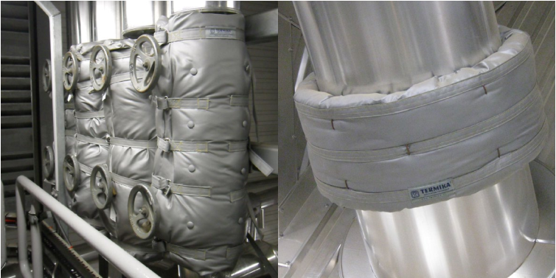

Use: thermal and acoustic insulation for industrial instalations (factories, district heating, heat and power plants, waste incinerators, gas distribution plants, petrochemical plants, refineries, offshore, shipbuilding, extractive industries).

Availability: on request

PRODUCT CHARACTERISTICS

 |  | thermal insulation mattresses are installed | designed individually for a given structure on the
 |  |  | basis of technical data provided by the customer
 |  | in places that are difficult to access, which
 |  |  | or after taking measurements by one of our
 |  | cannot be insulated in a traditional way
 |  |  | representatives
 |  | fabricated in any size and shape adapted | shape, thickness, assembly method is selected
 |  | to the existing installation | each time to the assumed expected parameters
 |  |  | in terms of resistance to high temperature of
 |  | provide excellent thermal and sound insulation | the working fabric, we make thermal insulation
 |  |  | mattresses up to 200°C or above 200°C
 |  | insulation mattresses are fabricated in the variant
 |  | intended for land indystries or marine and offshore

ADVANTAGES OF USING THERMAL INSULATION MATTRESSES

 |  | high durability of insulation | reduction of inspection downtime
 |  |  | and renovations
 |  | high flexibility and low weight enable insulation | protection against burns
 |  | in places where other systems cannot be used
 |  | multiple use, no need to dispose | protection of machines and other items
 |  | of post-renovation waste | against high temperatures
 |  | easy and clean disassembly by own staff, | proper operation of the device and minimization
 |  |  | of the risk of related failure with overheating
 |  | without the need for specialized training
 |  |  | of the machine
 |  | easy and quick access to places that require | perfect insulation of a given element
 |  | frequent inspections, renovations, service works

27

TAPES | FABRICS | INSULATION | INSULATION | FASTENING | SD STUDS CABLE TRAYS OTHERS
 |  | FASTENERS | MATTRESSES | TECHNIQUES

SPECIFICATION

Insulation mattresses are made of materials that are trimmed with technical fabrics using heat-resistant threads. Mattresses materials have a temperature resistance of up to 1000 °C. We use high quality glass, silicon, pasted, ceramic or aluminium coated fabrics. These fabrics are non-flammable, resistant to high temperatures, chemicals, molds and processes putrefaction, steam, water corrosion.

Depending on the conditions, operating temperature and customer requirements, felt, mineral and ceramic wool mats are used as the filling.

Mattresses are equipped with straps, cords, Velcro, hooks, clasps enabling easy and quick assembly / disassembly. This technical solution facilitates servicing, replacement of worn components or organizing planned commissioning of installations.

Use | mineral wool, ceramic mat, glass mat
fulfillment
Fabrics used | glass, siliconed, pasted, ceramic, fabric covered with aluminum
Fastening elements | belts, straps, hooks, buckles
Types of fasteners | different variants of joining individual fasteners
 | are possible depending on request

ADDITIONAL Possible types of thermal insulation mattresses are presented on the following pages.

INFORMATION

28

TAPES | FABRICS | INSULATION | INSULATION | FASTENING | SD STUDS CABLE TRAYS OTHERS
 |  | FASTENERS | MATTRESSES | TECHNIQUES

TYPE „A” (RECTANGULAR MATTRESS)

Product technical description:
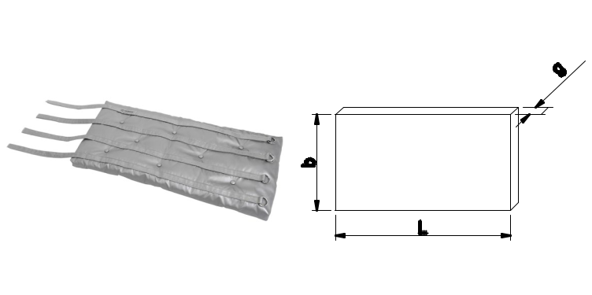

TL A1
 | TM | L x b x g
 |  | A2
 | e.g. TM-A1-1000 x 300 x 50
 | TL – onshore
 | TM – marine and offshore
 | A1 – work fabric up to 200°C
 | A2 – working fabric above 200°C
Mark | Dimension | Range
L (mm) | length | 20 - 2000
b (mm) | width | 20 - 2000
g (mm) | thickness | 25, 40, 60, 80, 100

TYPE „B” (RECTANGULAR MATTRESS WITH RECTANGULAR CUT)

Product technical description:

TL B1
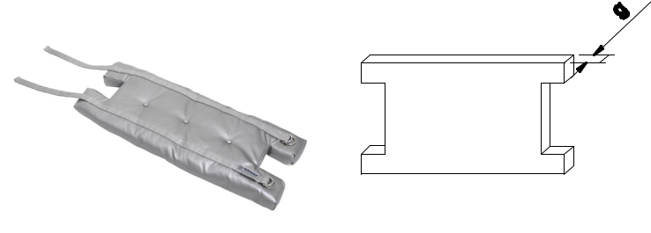
 | TM | L x b x g
 |  | B2
 | e.g. TM-B1-1000 x 300 x 50
 | TL – onshore
 | TM – marine and offshore
 | B1 – work fabric up to 200°C
 | B2 – working fabric above 200°C
Mark | Dimension | Range
L (mm) | length | 20 - 2000
b (mm) | width | 20 - 2000
+ g (mm) | thickness | 25, 40, 60, 80, 100
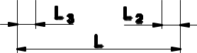

29

TAPES | FABRICS | INSULATION | INSULATION | FASTENING | SD STUDS CABLE TRAYS OTHERS
 |  | FASTENERS | MATTRESSES | TECHNIQUES

TYPE „C” (RECTANGULAR MATTRESS WITH ROUND CUT)

 | Product technical description:
 | TL | C1
 | TM | L x b x g
 |  | C2
 | e.g. TM-C1-1000 x 300 x 50
 | TL – onshore
 | TM – marine and offshore
 | C1 – work fabric up to 200°C
 | C2 – working fabric above 200°C
Mark | Dimension | Range
L (mm) | length | 20 - 2000
b (mm) | width | 20 - 2000
g (mm) | thickness | 25, 40, 60, 80, 100
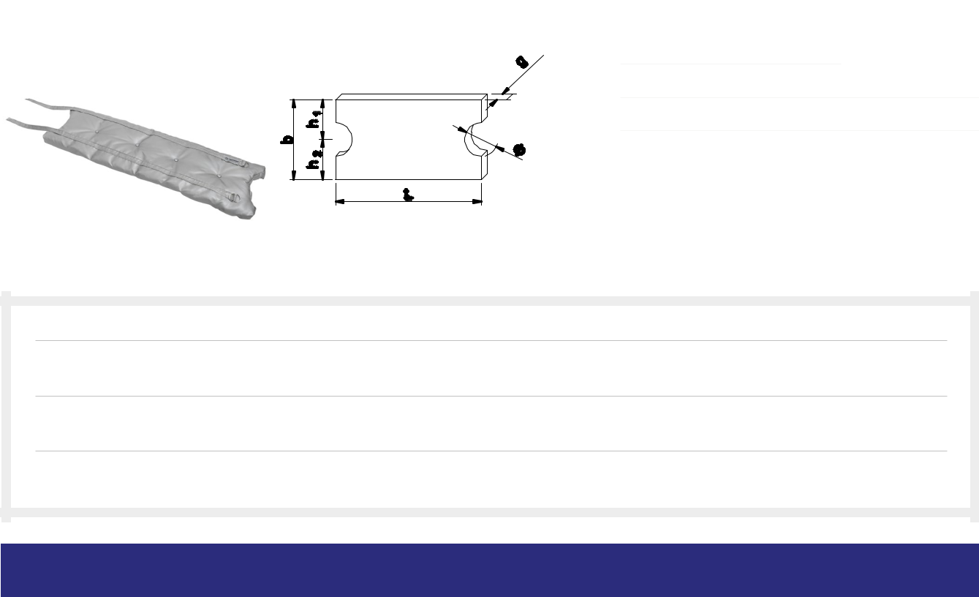

TYPE „D” (LID, WITH OR WITHOUT CUT)

Product technical description:
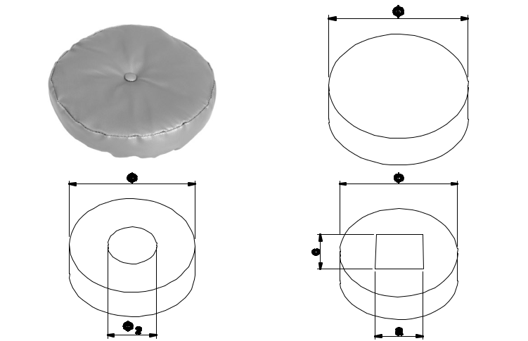

TL D1
Ø x g

TM D2

e.g. TL-D1-300 x 50

TL – onshore

TM – marine and offshore

D1 – work fabric up to 200°C

D2 – working fabric above 200°C

 |  | Mark | Dimension | Range
 |  | L (mm) | length | 20 - 2000
 |  | b (mm) | width | 20 - 2000
 |  | g (mm) | thickness | 25, 40, 60, 80, 100
 |  | Ø (mm) | thickness | 20 -1000

30

INSULA TION TECHNIQUE

TAPES | FABRICS | INSULATION | INSULATION | FASTENING | SD STUDS CABLE TRAYS OTHERS
 |  | FASTENERS | MATTRESSES | TECHNIQUES

TYPE „S” (TEE CONNECTOR INSULATION MATTRESS)

Product technical description:
TL | S1
 |  | L x b x g
TM
 | S2
e.g. TM-S1-1000 x 300 x 50
TL – onshore
TM – marine and offshore
S1 – work fabric up to 200°C
S2 – working fabric above 200°C
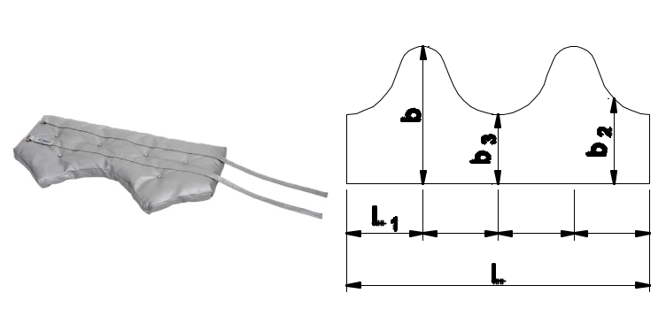

 |  | Mark |  | Dimension
 |  | L (mm) |  | total length
 |  | L₁ | (mm) | distance between the lowest and highest point
 |  | b (mm) |  | highest point
 |  | ^{b}2 | (mm) | average point
 |  | b₃ | (mm) | lowest point

TYPE „N” (ATYPICAL)

Product technical description:

TL | N1
 |  | L x b x g
TM
 | N2

np. TM-N1-300 x 50

TL – onshore

TM – marine and offshore

N1 – work fabric up to 200°C

N2 – working fabric above 200°C

31

TAPES | FABRICS | INSULATION | INSULATION
 |  | FASTENERS | MATTRESSES

FASTENING | SD STUDS CABLE TRAYS OTHERS
TECHNIQUES

THREADED STUD TYPE RD

Material: stainless steel, steel 4.8
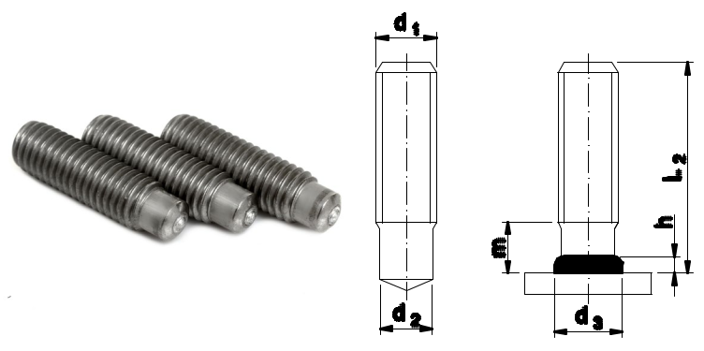

Use: threaded mounting studs with undercut threads and shafts come in a wide range of applications in the marine and land industry.

Availability: on request

Logistic minimum: 100 pcs/package

MATERIAL: STAINLESS STEEL

 |  | ^{d}1 | ^{L}2 | ^{d}2 | m ≈ | ^{d}3 | h ≈ | Ceramic Ring | Index
 |  | M6 | 15 | 4,7 | 4,5 | 6,5 | 2,5 | RF6 | T-05-RD1M6015
 |  | M6 | 20 | 4,7 | 4,5 | 6,5 | 2,5 | RF6 | T-05-RD1M6020
 |  | M6 | 25 | 4,7 | 4,5 | 6,5 | 2,5 | RF6 | T-05-RD1M6025
 |  | M6 | 30 | 4,7 | 4,5 | 6,5 | 2,5 | RF6 | T-05-RD1M6030
 |  | M6 | 35 | 4,7 | 4,5 | 6,5 | 2,5 | RF6 | T-05-RD1M6035
 |  | M6 | 40 | 4,7 | 4,5 | 6,5 | 2,5 | RF6 | T-05-RD1M6040
 |  | M6 | 45 | 4,7 | 4,5 | 6,5 | 2,5 | RF6 | T-05-RD1M6045
 |  | M6 | 50 | 4,7 | 4,5 | 6,5 | 2,5 | RF6 | T-05-RD1M6050
 |  | M8 | 20 | 6,2 | 4,5 | 8,8 | 2,5 | RF8 | T-05-RD1M8020
 |  | M8 | 25 | 6,2 | 4,5 | 8,8 | 2,5 | RF8 | T-05-RD1M8025
 |  | M8 | 30 | 6,2 | 4,5 | 8,8 | 2,5 | RF8 | T-05-RD1M8030
 |  | M8 | 35 | 6,2 | 4,5 | 8,8 | 2,5 | RF8 | T-05-RD1M8035
 |  | M8 | 40 | 6,2 | 4,5 | 8,8 | 2,5 | RF8 | T-05-RD1M8040
 |  | M8 | 45 | 6,2 | 4,5 | 8,8 | 2,5 | RF8 | T-05-RD1M8045
 |  | M8 | 50 | 6,2 | 4,5 | 8,8 | 2,5 | RF8 | T-05-RD1M8050
 |  | M10 | 20 | 7,9 | 5,0 | 11,0 | 3,0 | RF10 | T-05-RD1M10020
 |  | M10 | 25 | 7,9 | 5,0 | 11,0 | 3,0 | RF10 | T-05-RD1M10025
 |  | M10 | 30 | 7,9 | 5,0 | 11,0 | 3,0 | RF10 | T-05-RD1M10030
 |  | M10 | 35 | 7,9 | 5,0 | 11,0 | 3,0 | RF10 | T-05-RD1M10035
 |  | M10 | 40 | 7,9 | 5,0 | 11,0 | 3,0 | RF10 | T-05-RD1M10040
 |  | M10 | 45 | 7,9 | 5,0 | 11,0 | 3,0 | RF10 | T-05-RD1M10045
 |  | M10 | 50 | 7,9 | 5,0 | 11,0 | 3,0 | RF10 | T-05-RD1M10050
 |  | M10 | 55 | 7,9 | 5,0 | 11,0 | 3,0 | RF10 | T-05-RD1M10055
 |  | M10 | 60 | 7,9 | 5,0 | 11,0 | 3,0 | RF10 | T-05-RD1M10060
 |  | M12 | 20 | 9,5 | 6,5 | 13,0 | 4,0 | RF12 | T-05-RD1M12020
 |  | M12 | 25 | 9,5 | 6,5 | 13,0 | 4,0 | RF12 | T-05-RD1M12025
 |  | M12 | 30 | 9,5 | 6,5 | 13,0 | 4,0 | RF12 | T-05-RD1M12030
 |  | M12 | 35 | 9,5 | 6,5 | 13,0 | 4,0 | RF12 | T-05-RD1M12035
 |  | M12 | 40 | 9,5 | 6,5 | 13,0 | 4,0 | RF12 | T-05-RD1M12040
 |  | M12 | 45 | 9,5 | 6,5 | 13,0 | 4,0 | RF12 | T-05-RD1M12045
 |  | M12 | 50 | 9,5 | 6,5 | 13,0 | 4,0 | RF12 | T-05-RD1M12050
 |  | M12 | 55 | 9,5 | 6,5 | 13,0 | 4,0 | RF12 | T-05-RD1M12055
 |  | M12 | 60 | 9,5 | 6,5 | 13,0 | 4,0 | RF12 | T-05-RD1M12060
 |  | M16 | 30 | 13,2 | 11,0 | 17,0 | 5,0 | RF16 | T-05-RD1M16030
 |  | M16 | 35 | 13,2 | 11,0 | 17,0 | 5,0 | RF16 | T-05-RD1M16035
 |  | M16 | 40 | 13,2 | 11,0 | 17,0 | 5,0 | RF16 | T-05-RD1M16040
 |  | M16 | 45 | 13,2 | 11,0 | 17,0 | 5,0 | RF16 | T-05-RD1M16045
 |  | M16 | 50 | 13,2 | 11,0 | 17,0 | 5,0 | RF16 | T-05-RD1M16050
 |  | M16 | 55 | 13,2 | 11,0 | 17,0 | 5,0 | RF16 | T-05-RD1M16055
 |  | M16 | 60 | 13,2 | 11,0 | 17,0 | 5,0 | RF16 | T-05-RD1M16060
 |  | M16 | 65 | 13,2 | 11,0 | 17,0 | 5,0 | RF16 | T-05-RD1M16065

32

INSULA TION TECHNIQUE

TAPES | FABRICS | INSULATION | INSULATION
 |  | FASTENERS | MATTRESSES

FASTENING | SD STUDS CABLE TRAYS OTHERS
TECHNIQUES

 |  | d₁ | L₂ | d₂ | m ≈ | d₃ | h ≈ | Ceramic Ring | Index
 |  | M20 | 35 | 16,5 | 13,0 | 21,0 | 6,0 | RF20 | T-05-RD1M20035
 |  | M20 | 40 | 16,5 | 13,0 | 21,0 | 6,0 | RF20 | T-05-RD1M20040
 |  | M20 | 45 | 16,5 | 13,0 | 21,0 | 6,0 | RF20 | T-05-RD1M20045
 |  | M20 | 50 | 16,5 | 13,0 | 21,0 | 6,0 | RF20 | T-05-RD1M20050
 |  | M20 | 55 | 16,5 | 13,0 | 21,0 | 6,0 | RF20 | T-05-RD1M20055
 |  | M20 | 60 | 16,5 | 13,0 | 21,0 | 6,0 | RF20 | T-05-RD1M20060
 |  | M20 | 65 | 16,5 | 13,0 | 21,0 | 6,0 | RF20 | T-05-RD1M20065
 |  | M20 | 70 | 16,5 | 13,0 | 21,0 | 6,0 | RF20 | T-05-RD1M20070
 |  | M20 | 100 | 16,5 | 13,0 | 21,0 | 6,0 | RF20 | T-05-RD1M20100
 |  | MATERIAL: STEEL 4.8
 |  | ^{d}1 | ^{L}2 | ^{d}2 | m ≈ | ^{d}3 | h ≈ | Ceramic Ring | Index
 |  | M6 | 15 | 4,7 | 4,5 | 6,5 | 2,5 | RF6 | T-05-RD2M6015
 |  | M6 | 20 | 4,7 | 4,5 | 6,5 | 2,5 | RF6 | T-05-RD2M6020
 |  | M6 | 25 | 4,7 | 4,5 | 6,5 | 2,5 | RF6 | T-05-RD2M6025
 |  | M6 | 30 | 4,7 | 4,5 | 6,5 | 2,5 | RF6 | T-05-RD2M6030
 |  | M6 | 35 | 4,7 | 4,5 | 6,5 | 2,5 | RF6 | T-05-RD2M6035
 |  | M6 | 40 | 4,7 | 4,5 | 6,5 | 2,5 | RF6 | T-05-RD2M6040
 |  | M6 | 45 | 4,7 | 4,5 | 6,5 | 2,5 | RF6 | T-05-RD2M6045
 |  | M6 | 50 | 4,7 | 4,5 | 6,5 | 2,5 | RF6 | T-05-RD2M6050
 |  | M8 | 20 | 6,2 | 4,5 | 8,8 | 2,5 | RF8 | T-05-RD2M8020
 |  | M8 | 25 | 6,2 | 4,5 | 8,8 | 2,5 | RF8 | T-05-RD2M8025
 |  | M8 | 30 | 6,2 | 4,5 | 8,8 | 2,5 | RF8 | T-05-RD2M8030
 |  | M8 | 35 | 6,2 | 4,5 | 8,8 | 2,5 | RF8 | T-05-RD2M8035
 |  | M8 | 40 | 6,2 | 4,5 | 8,8 | 2,5 | RF8 | T-05-RD2M8040
 |  | M8 | 45 | 6,2 | 4,5 | 8,8 | 2,5 | RF8 | T-05-RD2M8045
 |  | M8 | 50 | 6,2 | 4,5 | 8,8 | 2,5 | RF8 | T-05-RD2M8050
 |  | M10 | 20 | 7,9 | 5,0 | 11,0 | 3,0 | RF10 | T-05-RD2M10020
 |  | M10 | 25 | 7,9 | 5,0 | 11,0 | 3,0 | RF10 | T-05-RD2M10025
 |  | M10 | 30 | 7,9 | 5,0 | 11,0 | 3,0 | RF10 | T-05-RD2M10030
 |  | M10 | 35 | 7,9 | 5,0 | 11,0 | 3,0 | RF10 | T-05-RD2M10035
 |  | M10 | 40 | 7,9 | 5,0 | 11,0 | 3,0 | RF10 | T-05-RD2M10040
 |  | M10 | 45 | 7,9 | 5,0 | 11,0 | 3,0 | RF10 | T-05-RD2M10045
 |  | M10 | 50 | 7,9 | 5,0 | 11,0 | 3,0 | RF10 | T-05-RD2M10050
 |  | M10 | 55 | 7,9 | 5,0 | 11,0 | 3,0 | RF10 | T-05-RD2M10055
 |  | M10 | 60 | 7,9 | 5,0 | 11,0 | 3,0 | RF10 | T-05-RD2M10060
 |  | M12 | 20 | 9,5 | 6,5 | 13,0 | 4,0 | RF12 | T-05-RD2M12020
 |  | M12 | 25 | 9,5 | 6,5 | 13,0 | 4,0 | RF12 | T-05-RD2M12025
 |  | M12 | 30 | 9,5 | 6,5 | 13,0 | 4,0 | RF12 | T-05-RD2M12030
 |  | M12 | 35 | 9,5 | 6,5 | 13,0 | 4,0 | RF12 | T-05-RD2M12035
 |  | M12 | 40 | 9,5 | 6,5 | 13,0 | 4,0 | RF12 | T-05-RD2M12040
 |  | M12 | 45 | 9,5 | 6,5 | 13,0 | 4,0 | RF12 | T-05-RD2M12045
 |  | M12 | 50 | 9,5 | 6,5 | 13,0 | 4,0 | RF12 | T-05-RD2M12050
 |  | M12 | 55 | 9,5 | 6,5 | 13,0 | 4,0 | RF12 | T-05-RD2M12055
 |  | M12 | 60 | 9,5 | 6,5 | 13,0 | 4,0 | RF12 | T-05-RD2M12060
 |  | M16 | 30 | 13,2 | 11,0 | 17,0 | 5,0 | RF16 | T-05-RD2M16030
 |  | M16 | 35 | 13,2 | 11,0 | 17,0 | 5,0 | RF16 | T-05-RD2M16035
 |  | M16 | 40 | 13,2 | 11,0 | 17,0 | 5,0 | RF16 | T-05-RD2M16040
 |  | M16 | 45 | 13,2 | 11,0 | 17,0 | 5,0 | RF16 | T-05-RD2M16045
 |  | M16 | 50 | 13,2 | 11,0 | 17,0 | 5,0 | RF16 | T-05-RD2M16050
 |  | M16 | 55 | 13,2 | 11,0 | 17,0 | 5,0 | RF16 | T-05-RD2M16055
 |  | M16 | 60 | 13,2 | 11,0 | 17,0 | 5,0 | RF16 | T-05-RD2M16060
 |  | M16 | 65 | 13,2 | 11,0 | 17,0 | 5,0 | RF16 | T-05-RD2M16065
 |  | M20 | 35 | 16,5 | 13,0 | 21,0 | 6,0 | RF20 | T-05-RD2M20035
 |  | M20 | 40 | 16,5 | 13,0 | 21,0 | 6,0 | RF20 | T-05-RD2M20040
 |  | M20 | 45 | 16,5 | 13,0 | 21,0 | 6,0 | RF20 | T-05-RD2M20045
 |  | M20 | 50 | 16,5 | 13,0 | 21,0 | 6,0 | RF20 | T-05-RD2M20050
 |  | M20 | 55 | 16,5 | 13,0 | 21,0 | 6,0 | RF20 | T-05-RD2M20055
 |  | M20 | 60 | 16,5 | 13,0 | 21,0 | 6,0 | RF20 | T-05-RD2M20060
 |  | M20 | 65 | 16,5 | 13,0 | 21,0 | 6,0 | RF20 | T-05-RD2M20065
 |  | M20 | 70 | 16,5 | 13,0 | 21,0 | 6,0 | RF20 | T-05-RD2M20070
 |  | M20 | 100 | 16,5 | 13,0 | 21,0 | 6,0 | RF20 | T-05-RD2M20100

Other dimensions available on request.
33

TAPES | FABRICS | INSULATION | INSULATION
 |  | FASTENERS | MATTRESSES

FASTENING | SD STUDS CABLE TRAYS OTHERS
TECHNIQUES

THREADED STUD TYPE DD

Material: stainless steel, steel 4.8
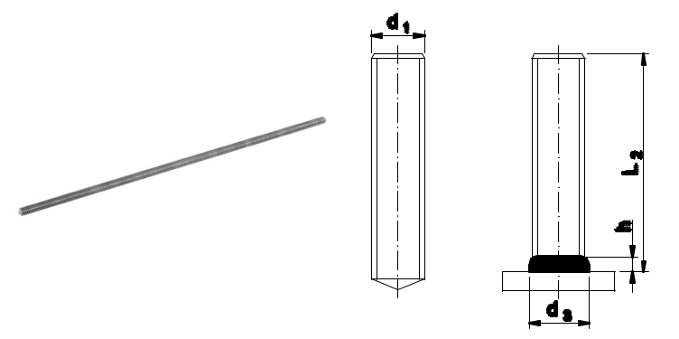

Use: mounting studs are fully threaded and usable in a wide range of marine and land industry.

Availability: on request

Logistic minimum: 100 pcs/package

MATERIAL: STAINLESS STEEL

 |  | ^{d}1 | ^{L}2 | ^{d}3 | h ≈ | Ceramic Ring | Index
 |  | M6 | 20 | 8,7 | 3,2 | UF6 | T-05-DD1M6020
 |  | M6 | 25 | 8,7 | 3,2 | UF6 | T-05-DD1M6025
 |  | M6 | 30 | 8,7 | 3,2 | UF6 | T-05-DD1M6030
 |  | M6 | 35 | 8,7 | 3,2 | UF6 | T-05-DD1M6035
 |  | M6 | 40 | 8,7 | 3,2 | UF6 | T-05-DD1M6040
 |  | M6 | 45 | 8,7 | 3,2 | UF6 | T-05-DD1M6045
 |  | M6 | 50 | 8,7 | 3,2 | UF6 | T-05-DD1M6050
 |  | M6 | 55 | 8,7 | 3,2 | UF6 | T-05-DD1M6055
 |  | M6 | 60 | 8,7 | 3,2 | UF6 | T-05-DD1M6060
 |  | M8 | 20 | 11,0 | 3,5 | UF8 | T-05-DD1M8020
 |  | M8 | 25 | 11,0 | 3,5 | UF8 | T-05-DD1M8025
 |  | M8 | 30 | 11,0 | 3,5 | UF8 | T-05-DD1M8030
 |  | M8 | 35 | 11,0 | 3,5 | UF8 | T-05-DD1M8035
 |  | M8 | 40 | 11,0 | 3,5 | UF8 | T-05-DD1M8040
 |  | M8 | 45 | 11,0 | 3,5 | UF8 | T-05-DD1M8045
 |  | M8 | 50 | 11,0 | 3,5 | UF8 | T-05-DD1M8050
 |  | M8 | 55 | 11,0 | 3,5 | UF8 | T-05-DD1M8055
 |  | M8 | 60 | 11,0 | 3,5 | UF8 | T-05-DD1M8060
 |  | M10 | 20 | 13,5 | 3,5 | UF10 | T-05-DD1M10020
 |  | M10 | 25 | 13,5 | 3,5 | UF10 | T-05-DD1M10025
 |  | M10 | 30 | 13,5 | 3,5 | UF10 | T-05-DD1M10030
 |  | M10 | 35 | 13,5 | 3,5 | UF10 | T-05-DD1M10035
 |  | M10 | 40 | 13,5 | 3,5 | UF10 | T-05-DD1M10040
 |  | M10 | 45 | 13,5 | 3,5 | UF10 | T-05-DD1M10045
 |  | M10 | 50 | 13,5 | 3,5 | UF10 | T-05-DD1M10050
 |  | M10 | 55 | 13,5 | 3,5 | UF10 | T-05-DD1M10055
 |  | M10 | 60 | 13,5 | 3,5 | UF10 | T-05-DD1M10060
 |  | M12 | 20 | 15,5 | 4,5 | UF12 | T-05-DD1M12020
 |  | M12 | 25 | 15,5 | 4,5 | UF12 | T-05-DD1M12025
 |  | M12 | 30 | 15,5 | 4,5 | UF12 | T-05-DD1M12030
 |  | M12 | 35 | 15,5 | 4,5 | UF12 | T-05-DD1M12035
 |  | M12 | 40 | 15,5 | 4,5 | UF12 | T-05-DD1M12040
 |  | M12 | 45 | 15,5 | 4,5 | UF12 | T-05-DD1M12045
 |  | M12 | 50 | 15,5 | 4,5 | UF12 | T-05-DD1M12050
 |  | M12 | 55 | 15,5 | 4,5 | UF12 | T-05-DD1M12055
 |  | M12 | 60 | 15,5 | 4,5 | UF12 | T-05-DD1M12060
 |  | M16 | 30 | 20,5 | 7,0 | UF16 | T-05-DD1M16030
 |  | M16 | 35 | 20,5 | 7,0 | UF16 | T-05-DD1M16035
 |  | M16 | 40 | 20,5 | 7,0 | UF16 | T-05-DD1M16040
 |  | M16 | 45 | 20,5 | 7,0 | UF16 | T-05-DD1M16045
 |  | M16 | 50 | 20,5 | 7,0 | UF16 | T-05-DD1M16050
 |  | M16 | 55 | 20,5 | 7,0 | UF16 | T-05-DD1M16055
 |  | M16 | 60 | 20,5 | 7,0 | UF16 | T-05-DD1M16060
 |  | M16 | 65 | 20,5 | 7,0 | UF16 | T-05-DD1M16065

34

INSULA TION TECHNIQUE

TAPES | FABRICS | INSULATION | INSULATION
 |  | FASTENERS | MATTRESSES

FASTENING | SD STUDS CABLE TRAYS OTHERS
TECHNIQUES

MATERIAL: STEEL 4.8

 |  | ^{d}1 | ^{L}2 | ^{d}3 | h ≈ | Ceramic Ring | Index
 |  | M6 | 20 | 8,7 | 3,2 | UF6 | T-05-DD2M6020
 |  | M6 | 25 | 8,7 | 3,2 | UF6 | T-05-DD2M6025
 |  | M6 | 30 | 8,7 | 3,2 | UF6 | T-05-DD2M6030
 |  | M6 | 35 | 8,7 | 3,2 | UF6 | T-05-DD2M6035
 |  | M6 | 40 | 8,7 | 3,2 | UF6 | T-05-DD2M6040
 |  | M6 | 45 | 8,7 | 3,2 | UF6 | T-05-DD2M6045
 |  | M6 | 50 | 8,7 | 3,2 | UF6 | T-05-DD2M6050
 |  | M6 | 55 | 8,7 | 3,2 | UF6 | T-05-DD2M6055
 |  | M6 | 60 | 8,7 | 3,2 | UF6 | T-05-DD2M6060
 |  | M8 | 20 | 11,0 | 3,5 | UF8 | T-05-DD2M8020
 |  | M8 | 25 | 11,0 | 3,5 | UF8 | T-05-DD2M8025
 |  | M8 | 30 | 11,0 | 3,5 | UF8 | T-05-DD2M8030
 |  | M8 | 35 | 11,0 | 3,5 | UF8 | T-05-DD2M8035
 |  | M8 | 40 | 11,0 | 3,5 | UF8 | T-05-DD2M8040
 |  | M8 | 45 | 11,0 | 3,5 | UF8 | T-05-DD2M8045
 |  | M8 | 50 | 11,0 | 3,5 | UF8 | T-05-DD2M8050
 |  | M8 | 55 | 11,0 | 3,5 | UF8 | T-05-DD2M8055
 |  | M8 | 60 | 11,0 | 3,5 | UF8 | T-05-DD2M8060
 |  | M10 | 20 | 13,5 | 3,5 | UF10 | T-05-DD2M10020
 |  | M10 | 25 | 13,5 | 3,5 | UF10 | T-05-DD2M10025
 |  | M10 | 30 | 13,5 | 3,5 | UF10 | T-05-DD2M10030
 |  | M10 | 35 | 13,5 | 3,5 | UF10 | T-05-DD2M10035
 |  | M10 | 40 | 13,5 | 3,5 | UF10 | T-05-DD2M10040
 |  | M10 | 45 | 13,5 | 3,5 | UF10 | T-05-DD2M10045
 |  | M10 | 50 | 13,5 | 3,5 | UF10 | T-05-DD2M10050
 |  | M10 | 55 | 13,5 | 3,5 | UF10 | T-05-DD2M10055
 |  | M10 | 60 | 13,5 | 3,5 | UF10 | T-05-DD2M10060
 |  | M12 | 20 | 15,5 | 4,5 | UF12 | T-05-DD2M12020
 |  | M12 | 25 | 15,5 | 4,5 | UF12 | T-05-DD2M12025
 |  | M12 | 30 | 15,5 | 4,5 | UF12 | T-05-DD2M12030
 |  | M12 | 35 | 15,5 | 4,5 | UF12 | T-05-DD2M12035
 |  | M12 | 40 | 15,5 | 4,5 | UF12 | T-05-DD2M12040
 |  | M12 | 45 | 15,5 | 4,5 | UF12 | T-05-DD2M12045
 |  | M12 | 50 | 15,5 | 4,5 | UF12 | T-05-DD2M12050
 |  | M12 | 55 | 15,5 | 4,5 | UF12 | T-05-DD2M12055
 |  | M12 | 60 | 15,5 | 4,5 | UF12 | T-05-DD2M12060
 |  | M16 | 30 | 20,5 | 7,0 | UF16 | T-05-DD2M16030
 |  | M16 | 35 | 20,5 | 7,0 | UF16 | T-05-DD2M16035
 |  | M16 | 40 | 20,5 | 7,0 | UF16 | T-05-DD2M16040
 |  | M16 | 45 | 20,5 | 7,0 | UF16 | T-05-DD2M16045
 |  | M16 | 50 | 20,5 | 7,0 | UF16 | T-05-DD2M16050
 |  | M16 | 55 | 20,5 | 7,0 | UF16 | T-05-DD2M16055
 |  | M16 | 60 | 20,5 | 7,0 | UF16 | T-05-DD2M16060
 |  | M16 | 65 | 20,5 | 7,0 | UF16 | T-05-DD2M16065

ADDITIONAL Standard lengths up to 100mm available. Other dimensions available on request.

INFORMATION

35

TAPES | FABRICS | INSULATION | INSULATION
 |  | FASTENERS | MATTRESSES

FASTENING | SD STUDS CABLE TRAYS OTHERS
TECHNIQUES

UNTHREADED STUD TYPE UD

Material: stainless steel, steel 4.8
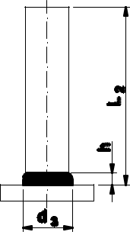

Use: unthreaded mounting studs come in a wide range of applications in the marine and land industry.
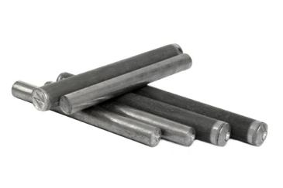

Availability: on request

Logistic minimum: 100 pcs/package

MATERIAL: STAINLESS STEEL

 |  | ^{d}1 | ^{L}2 | ^{d}3 | h ≈ | Ferrule | Index
 |  | 6 | 20 | 8,5 | 4,0 | UF6 | T-05-UD16020
 |  | 6 | 25 | 8,5 | 4,0 | UF6 | T-05-UD16025
 |  | 6 | 30 | 8,5 | 4,0 | UF6 | T-05-UD16030
 |  | 6 | 35 | 8,5 | 4,0 | UF6 | T-05-UD16035
 |  | 6 | 40 | 8,5 | 4,0 | UF6 | T-05-UD16040
 |  | 6 | 45 | 8,5 | 4,0 | UF6 | T-05-UD16045
 |  | 6 | 50 | 8,5 | 4,0 | UF6 | T-05-UD16050
 |  | 6 | 55 | 8,5 | 4,0 | UF6 | T-05-UD16055
 |  | 6 | 60 | 8,5 | 4,0 | UF6 | T-05-UD16060
 |  | 8 | 20 | 11,0 | 4,0 | UF8 | T-05-UD18020
 |  | 8 | 25 | 11,0 | 4,0 | UF8 | T-05-UD18025
 |  | 8 | 30 | 11,0 | 4,0 | UF8 | T-05-UD18030
 |  | 8 | 35 | 11,0 | 4,0 | UF8 | T-05-UD18035
 |  | 8 | 40 | 11,0 | 4,0 | UF8 | T-05-UD18040
 |  | 8 | 45 | 11,0 | 4,0 | UF8 | T-05-UD18045
 |  | 8 | 50 | 11,0 | 4,0 | UF8 | T-05-UD18050
 |  | 8 | 55 | 11,0 | 4,0 | UF8 | T-05-UD18055
 |  | 8 | 60 | 11,0 | 4,0 | UF8 | T-05-UD18060
 |  | 10 | 20 | 13,0 | 4,0 | UF10 | T-05-UD110020
 |  | 10 | 25 | 13,0 | 4,0 | UF10 | T-05-UD110025
 |  | 10 | 30 | 13,0 | 4,0 | UF10 | T-05-UD110030
 |  | 10 | 35 | 13,0 | 4,0 | UF10 | T-05-UD110035
 |  | 10 | 40 | 13,0 | 4,0 | UF10 | T-05-UD110040
 |  | 10 | 45 | 13,0 | 4,0 | UF10 | T-05-UD110045
 |  | 10 | 50 | 13,0 | 4,0 | UF10 | T-05-UD110050
 |  | 10 | 55 | 13,0 | 4,0 | UF10 | T-05-UD110055
 |  | 10 | 60 | 13,0 | 4,0 | UF10 | T-05-UD110060
 |  | 12 | 20 | 16,0 | 4,0 | UF12 | T-05-UD112020
 |  | 12 | 25 | 16,0 | 4,0 | UF12 | T-05-UD112025
 |  | 12 | 30 | 16,0 | 4,0 | UF12 | T-05-UD112030
 |  | 12 | 35 | 16,0 | 4,0 | UF12 | T-05-UD112035
 |  | 12 | 40 | 16,0 | 4,0 | UF12 | T-05-UD112040
 |  | 12 | 45 | 16,0 | 4,0 | UF12 | T-05-UD112045
 |  | 12 | 50 | 16,0 | 4,0 | UF12 | T-05-UD112050
 |  | 12 | 55 | 16,0 | 4,0 | UF12 | T-05-UD112055
 |  | 12 | 60 | 16,0 | 4,0 | UF12 | T-05-UD112060
 |  | 16 | 30 | 20,0 | 4,0 | UF16 | T-05-UD116030
 |  | 16 | 35 | 20,0 | 4,0 | UF16 | T-05-UD116035
 |  | 16 | 40 | 20,0 | 4,0 | UF16 | T-05-UD116040
 |  | 16 | 45 | 20,0 | 4,0 | UF16 | T-05-UD116045
 |  | 16 | 50 | 20,0 | 4,0 | UF16 | T-05-UD116050
 |  | 16 | 55 | 20,0 | 4,0 | UF16 | T-05-UD116055
 |  | 16 | 60 | 20,0 | 4,0 | UF16 | T-05-UD116060
 |  | 16 | 65 | 20,0 | 4,0 | UF16 | T-05-UD116065

36

INSULA TION TECHNIQUE

TAPES | FABRICS | INSULATION | INSULATION
 |  | FASTENERS | MATTRESSES

FASTENING | SD STUDS CABLE TRAYS OTHERS
TECHNIQUES

MATERIAL: STEEL 4.8

 |  | d₁ | L₂ | d₃ | h ≈ | Ferrule | Index
 |  | 6 | 20 | 8,5 | 4,0 | UF6 | T-05-UD26020
 |  | 6 | 25 | 8,5 | 4,0 | UF6 | T-05-UD26025
 |  | 6 | 30 | 8,5 | 4,0 | UF6 | T-05-UD26030
 |  | 6 | 35 | 8,5 | 4,0 | UF6 | T-05-UD26035
 |  | 6 | 40 | 8,5 | 4,0 | UF6 | T-05-UD26040
 |  | 6 | 45 | 8,5 | 4,0 | UF6 | T-05-UD26045
 |  | 6 | 50 | 8,5 | 4,0 | UF6 | T-05-UD26050
 |  | 6 | 55 | 8,5 | 4,0 | UF6 | T-05-UD26055
 |  | 6 | 60 | 8,5 | 4,0 | UF6 | T-05-UD26060
 |  | 8 | 20 | 11,0 | 4,0 | UF8 | T-05-UD28020
 |  | 8 | 25 | 11,0 | 4,0 | UF8 | T-05-UD28025
 |  | 8 | 30 | 11,0 | 4,0 | UF8 | T-05-UD28030
 |  | 8 | 35 | 11,0 | 4,0 | UF8 | T-05-UD28035
 |  | 8 | 40 | 11,0 | 4,0 | UF8 | T-05-UD28040
 |  | 8 | 45 | 11,0 | 4,0 | UF8 | T-05-UD28045
 |  | 8 | 50 | 11,0 | 4,0 | UF8 | T-05-UD28050
 |  | 8 | 55 | 11,0 | 4,0 | UF8 | T-05-UD28055
 |  | 8 | 60 | 11,0 | 4,0 | UF8 | T-05-UD28060
 |  | 10 | 20 | 13,0 | 4,0 | UF10 | T-05-UD210020
 |  | 10 | 25 | 13,0 | 4,0 | UF10 | T-05-UD210025
 |  | 10 | 30 | 13,0 | 4,0 | UF10 | T-05-UD210030
 |  | 10 | 35 | 13,0 | 4,0 | UF10 | T-05-UD210035
 |  | 10 | 40 | 13,0 | 4,0 | UF10 | T-05-UD210040
 |  | 10 | 45 | 13,0 | 4,0 | UF10 | T-05-UD210045
 |  | 10 | 50 | 13,0 | 4,0 | UF10 | T-05-UD210050
 |  | 10 | 55 | 13,0 | 4,0 | UF10 | T-05-UD210055
 |  | 10 | 60 | 13,0 | 4,0 | UF10 | T-05-UD210060
 |  | 12 | 20 | 16,0 | 4,0 | UF12 | T-05-UD212020
 |  | 12 | 25 | 16,0 | 4,0 | UF12 | T-05-UD212025
 |  | 12 | 30 | 16,0 | 4,0 | UF12 | T-05-UD212030
 |  | 12 | 35 | 16,0 | 4,0 | UF12 | T-05-UD212035
 |  | 12 | 40 | 16,0 | 4,0 | UF12 | T-05-UD212040
 |  | 12 | 45 | 16,0 | 4,0 | UF12 | T-05-UD212045
 |  | 12 | 50 | 16,0 | 4,0 | UF12 | T-05-UD212050
 |  | 12 | 55 | 16,0 | 4,0 | UF12 | T-05-UD212055
 |  | 12 | 60 | 16,0 | 4,0 | UF12 | T-05-UD212060
 |  | 16 | 30 | 20,0 | 4,0 | UF16 | T-05-UD216030
 |  | 16 | 35 | 20,0 | 4,0 | UF16 | T-05-UD216035
 |  | 16 | 40 | 20,0 | 4,0 | UF16 | T-05-UD216040
 |  | 16 | 45 | 20,0 | 4,0 | UF16 | T-05-UD216045
 |  | 16 | 50 | 20,0 | 4,0 | UF16 | T-05-UD216050
 |  | 16 | 55 | 20,0 | 4,0 | UF16 | T-05-UD216055
 |  | 16 | 60 | 20,0 | 4,0 | UF16 | T-05-UD216060
 |  | 16 | 65 | 20,0 | 4,0 | UF16 | T-05-UD216065

ADDDITIONAL Standard lengths up to 100mm available. Other dimensions available on request.

INFORMATION

37

_{TAPES} _{FABRICS} INSULATION INSULATION FASTENING
FASTENERS MATTRESSES TECHNIQUES

SD STUDS CABLE TRAYS OTHERS

HEADED STUD SD

Material: structural steel S235J2+C450
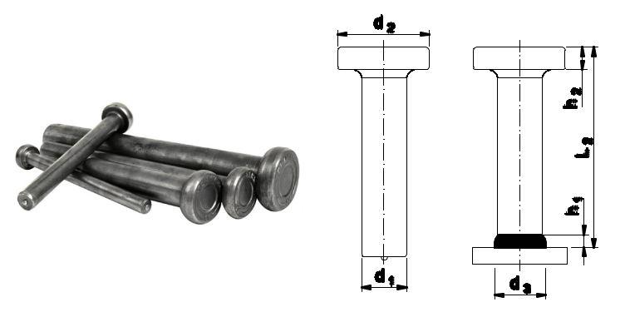

or S355J2+C450

Use: studs are welded on the surface of steel structures, the studs poured with concrete creates the kind of connector between steel construction and concrete. It has European Technical Approval and CE.

Availability: in stock

Logistic minimum: 100 pcs/package

MATERIAL: STRUCTURAL STEEL S235J2

 |  | d₁ | L₂ | h₁ | d₂ | d₃ | h₂ | Index
 | 10 |  | 50 | 2,5 | 19 | 13 | 7 | T-06-SD10050
 | 10 |  | 75 | 2,5 | 19 | 13 | 7 | T-06-SD10075
 | 10 |  | 100 | 2,5 | 19 | 13 | 7 | T-06-SD10100
 | 10 |  | 125 | 2,5 | 19 | 13 | 7 | T-06-SD10125
 | 10 |  | 150 | 2,5 | 19 | 13 | 7 | T-06-SD10150
 | 10 |  | 175 | 2,5 | 19 | 13 | 7 | T-06-SD10175
 | 10 |  | 200 | 2,5 | 19 | 13 | 7 | T-06-SD10200
 | 13 |  | 50 | 3 | 25 | 17 | 8 | T-06-SD13050
 | 13 |  | 75 | 3 | 25 | 17 | 8 | T-06-SD13075
 | 13 |  | 100 | 3 | 25 | 17 | 8 | T-06-SD13100
 | 13 |  | 125 | 3 | 25 | 17 | 8 | T-06-SD13125
 | 13 |  | 150 | 3 | 25 | 17 | 8 | T-06-SD13150
 | 13 |  | 175 | 3 | 25 | 17 | 8 | T-06-SD13175
 | 13 |  | 200 | 3 | 25 | 17 | 8 | T-06-SD13200
 | 13 |  | 225 | 3 | 25 | 17 | 8 | T-06-SD13225
 | 13 |  | 250 | 3 | 25 | 17 | 8 | T-06-SD13250
 | 13 |  | 300 | 3 | 25 | 17 | 8 | T-06-SD13300
 | 13 |  | 350 | 3 | 25 | 17 | 8 | T-06-SD13350
 | 13 |  | 400 | 3 | 25 | 17 | 8 | T-06-SD13400
 | 16 |  | 50 | 4,5 | 32 | 21 | 8 | T-06-SD16050
 | 16 |  | 75 | 4,5 | 32 | 21 | 8 | T-06-SD16075
 | 16 |  | 100 | 4,5 | 32 | 21 | 8 | T-06-SD16100
 | 16 |  | 125 | 4,5 | 32 | 21 | 8 | T-06-SD16125
 | 16 |  | 150 | 4,5 | 32 | 21 | 8 | T-06-SD16150
 | 16 |  | 175 | 4,5 | 32 | 21 | 8 | T-06-SD16175
 | 16 |  | 200 | 4,5 | 32 | 21 | 8 | T-06-SD16200
 | 16 |  | 225 | 4,5 | 32 | 21 | 8 | T-06-SD16225
 | 16 |  | 250 | 4,5 | 32 | 21 | 8 | T-06-SD16250
 | 16 |  | 275 | 4,5 | 32 | 21 | 8 | T-06-SD16275
 | 16 |  | 300 | 4,5 | 32 | 21 | 8 | T-06-SD16300
 | 16 |  | 350 | 4,5 | 32 | 21 | 8 | T-06-SD16350
 | 16 |  | 400 | 4,5 | 32 | 21 | 8 | T-06-SD16400
 | 16 |  | 525 | 4,5 | 32 | 21 | 8 | T-06-SD16525

38

INSULA TION TECHNIQUE

_{TAPES} _{FABRICS} INSULATION INSULATION FASTENING
FASTENERS MATTRESSES TECHNIQUES

SD STUDS CABLE TRAYS OTHERS

 |  | ^{d}1 | ^{L}2 | ^{h}1 | ^{d}2 | ^{d}3 | ^{h}2 | Index
 | 19 |  | 75 | 6 | 32 | 23 | 10 | T-06-SD19075
 | 19 |  | 80 | 6 | 32 | 23 | 10 | T-06-SD19080
 | 19 |  | 90 | 6 | 32 | 23 | 10 | T-06-SD19090
 | 19 |  | 100 | 6 | 32 | 23 | 10 | T-06-SD19100
 | 19 |  | 125 | 6 | 32 | 23 | 10 | T-06-SD19125
 | 19 |  | 150 | 6 | 32 | 23 | 10 | T-06-SD19150
 | 19 |  | 175 | 6 | 32 | 23 | 10 | T-06-SD19175
 | 19 |  | 200 | 6 | 32 | 23 | 10 | T-06-SD19200
 | 19 |  | 225 | 6 | 32 | 23 | 10 | T-06-SD19225
 | 19 |  | 250 | 6 | 32 | 23 | 10 | T-06-SD19250
 | 19 |  | 275 | 6 | 32 | 23 | 10 | T-06-SD19275
 | 19 |  | 300 | 6 | 32 | 23 | 10 | T-06-SD19300
 | 19 |  | 350 | 6 | 32 | 23 | 10 | T-06-SD19350
 | 19 |  | 400 | 6 | 32 | 23 | 10 | T-06-SD19400
 | 19 |  | 525 | 6 | 32 | 23 | 10 | T-06-SD19525
 | 22 |  | 75 | 6 | 35 | 29 | 10 | T-06-SD22075
 | 22 |  | 90 | 6 | 35 | 29 | 10 | T-06-SD22090
 | 22 |  | 100 | 6 | 35 | 29 | 10 | T-06-SD22100
 | 22 |  | 125 | 6 | 35 | 29 | 10 | T-06-SD22125
 | 22 |  | 150 | 6 | 35 | 29 | 10 | T-06-SD22150
 | 22 |  | 175 | 6 | 35 | 29 | 10 | T-06-SD22175
 | 22 |  | 200 | 6 | 35 | 29 | 10 | T-06-SD22200
 | 22 |  | 225 | 6 | 35 | 29 | 10 | T-06-SD22225
 | 22 |  | 250 | 6 | 35 | 29 | 10 | T-06-SD22250
 | 22 |  | 300 | 6 | 35 | 29 | 10 | T-06-SD22300
 | 22 |  | 350 | 6 | 35 | 29 | 10 | T-06-SD22350
 | 22 |  | 400 | 6 | 35 | 29 | 10 | T-06-SD22400
 | 22 |  | 450 | 6 | 35 | 29 | 10 | T-06-SD22450
 | 22 |  | 525 | 6 | 35 | 29 | 10 | T-06-SD22525
 | 25* |  | 75 | 7 | 40 | 31 | 12 | T-06-SD25075
 | 25 |  | 100 | 7 | 40 | 31 | 12 | T-06-SD25100
 | 25 |  | 125 | 7 | 40 | 31 | 12 | T-06-SD25125
 | 25 |  | 150 | 7 | 40 | 31 | 12 | T-06-SD25150
 | 25 |  | 175 | 7 | 40 | 31 | 12 | T-06-SD25175
 | 25 |  | 200 | 7 | 40 | 31 | 12 | T-06-SD25200
 | 25 |  | 225 | 7 | 40 | 31 | 12 | T-06-SD25225
 | 25 |  | 250 | 7 | 40 | 31 | 12 | T-06-SD25250
 | 25 |  | 300 | 7 | 40 | 31 | 12 | T-06-SD25300
 | 25 |  | 350 | 7 | 40 | 31 | 12 | T-06-SD25350
 | 25 |  | 400 | 7 | 40 | 31 | 12 | T-06-SD25400
 | 25 |  | 450 | 7 | 40 | 31 | 12 | T-06-SD25450
 | 25 |  | 525 | 7 | 40 | 31 | 12 | T-06-SD25525

* during the approval process conducted by ITB

ADDITIONAL Other dimensions available on request.

INFORMATION

39

TAPES | FABRICS | INSULATION | INSULATION | FASTENING | SD STUDS | CABLE TRAYS OTHERS
 |  | FASTENERS | MATTRESSES | TECHNIQUES

OPEN CABLE HANGER

Material: copper covered steel,
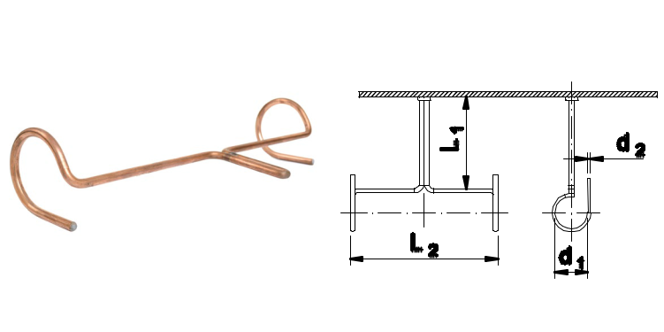

stainless steel 1.4301

Use: the system of hangs usable during the cable installation.

Availability: in stock

Logistic minimum: 50 pcs/package

MATERIAL: COPPER COVERED STEEL

 |  | Name | L₁ | L₂ | d₁ | d₂ | Index
 |  | Open cable hanger 60 | 60 | 280 | 45 | 6 | T-07-001
 |  | Open cable hanger 100 | 100 | 280 | 45 | 6 | T-07-002
 |  | Open cable hanger 150 | 150 | 280 | 45 | 6 | T-07-003
 |  | Open cable hanger 250 | 250 | 280 | 45 | 6 | T-07-004

MATERIAL: STAINLESS STEEL 1.4301

 |  | Name | L₁ | L₂ | d₁ | d₂ | Index
 |  | Open cable hanger 60 | 60 | 280 | 45 | 6 | T-07-005
 |  | Open cable hanger 100 | 100 | 280 | 45 | 6 | T-07-006
 |  | Open cable hanger 150 | 150 | 280 | 45 | 6 | T-07-007
 |  | Open cable hanger 250 | 250 | 280 | 45 | 6 | T-07-008

ADDITIONAL Other dimensions and materials are available on request.

INFORMATION

40

INSULA TION TECHNIQUE

TAPES | FABRICS | INSULATION | INSULATION | FASTENING | SD STUDS | CABLE TRAYS OTHERS
 |  | FASTENERS | MATTRESSES | TECHNIQUES

CLOSED CABLE HANGER

Material: copper covered steel,

stainless steel 1.4301
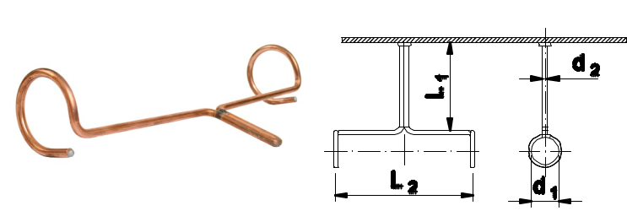

Use: the system of hangs usable during the cable installation.

Availability: in stock

Logistic minimum: 50 pcs/package

MATERIAL: COPPER COVERED STEEL

 |  | Name | L₁ | L₂ | d₁ | d₂ | Index
 |  | Closed cable hanger 60 | 60 | 280 | 45 | 6 | T-07-009
 |  | Closed cable hanger 100 | 100 | 280 | 45 | 6 | T-07-010
 |  | Closed cable hanger 150 | 150 | 280 | 45 | 6 | T-07-011
 |  | Closed cable hanger 250 | 250 | 280 | 45 | 6 | T-07-012

MATERIAL: STAINLESS STEEL 1.4301

 |  | Name | L₁ | L₂ | d₁ | d₂ | Index
 |  | Closed cable hanger 60 | 60 | 280 | 45 | 6 | T-07-013
 |  | Closed cable hanger 100 | 100 | 280 | 45 | 6 | T-07-014
 |  | Closed cable hanger 150 | 150 | 280 | 45 | 6 | T-07-015
 |  | Closed cable hanger 250 | 250 | 280 | 45 | 6 | T-07-016

ADDITIONAL Other dimensions and materials are available on request.

INFORMATION

41

TAPES | FABRICS | INSULATION | INSULATION | FASTENING | SD STUDS | CABLE TRAYS OTHERS
 |  | FASTENERS | MATTRESSES | TECHNIQUES

FLAT BAR CABLE HANGER

Material: galvanized steel
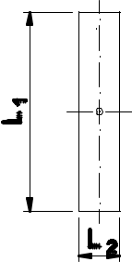

Use: the system of hangs usable during the cable installation.
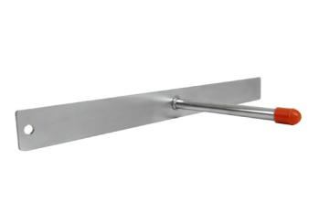
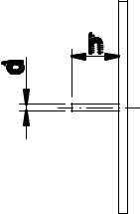

Availability: in stock

Logistic minimum: 100 pcs/package

MATERIAL: GALVANIZED STEEL

 |  | Name | L₁ | L₂ | d | h | m | Index
 |  | Flat bar hanger 320x30x40 | 320 | 30 | 10 | 40 | 3 | T-07-021
 |  | Flat bar hanger 320x30x120 | 320 | 30 | 10 | 120 | 3 | T-07-022
 |  | Flat bar hanger 320x50x40 | 320 | 50 | 10 | 40 | 3 | T-07-023
 |  | Flat bar hanger 320x50x120 | 320 | 50 | 10 | 120 | 3 | T-07-024

ADDITIONAL Other dimensions and materials are available on request.

INFORMATION

42

INSULA TION TECHNIQUE

TAPES | FABRICS | INSULATION | INSULATION | FASTENING | SD STUDS | CABLE TRAYS OTHERS
 |  | FASTENERS | MATTRESSES | TECHNIQUES

CABLE HANGER TYPE H

Material: galvanized steel
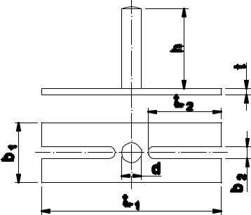

Use: slings system welded on both sides, used during cabling assembly.
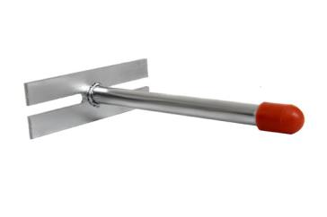

Availability: on request

MATERIAL: GALVANIZED STEEL

 |  | Name | b₁ | b₂ | d | h | L₁ | L₂ | t | Index
 |  | Cable hanger type h90 | 30 | 6 | 10 | 40 | 90 | 37 | 3 | T-07-025
 |  | Cable hanger type h120 | 30 | 6 | 10 | 40 | 110 | 47 | 3 | T-07-026

ADDITIONAL Other dimensions and materials are available on request.

INFORMATION

43

TAPES | FABRICS | INSULATION | INSULATION | FASTENING | SD STUDS CABLE TRAYS | OTHERS
 |  | FASTENERS | MATTRESSES | TECHNIQUES

ROUND SUPPORT

Material: galvanized steel
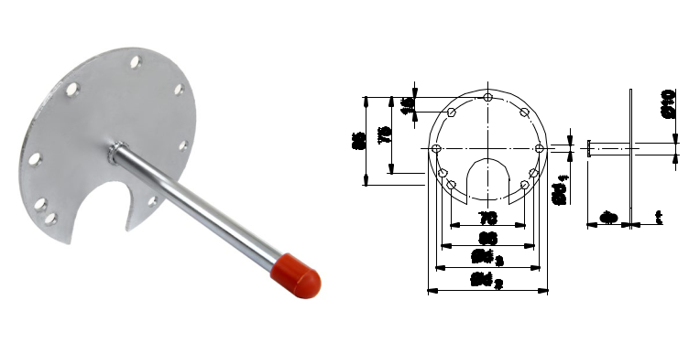

Use: welded bracket, used for fixing electrical equipment on ships. Support fitting for electrical equipment

Availability: on request

MATERIAL: GALVANIZED STEEL

 |  | Name | d₁ | d₂ | d₃ | L | t | Index
 |  | Round support 40 | 7,5 | 115 | 100 | 40 | 3 | T-07-30
 |  | Round support 120 | 7,5 | 115 | 100 | 120 | 3 | T-07-31

ADDITIONAL Other dimensions and materials are available on request.

INFORMATION

44

INSULA TION TECHNIQUE

TAPES | FABRICS | INSULATION | INSULATION | FASTENING | SD STUDS CABLE TRAYS | OTHERS
 |  | FASTENERS | MATTRESSES | TECHNIQUES

OMEGA CONNECTOR

Material: galvanized steel, stainless steel 1.4301
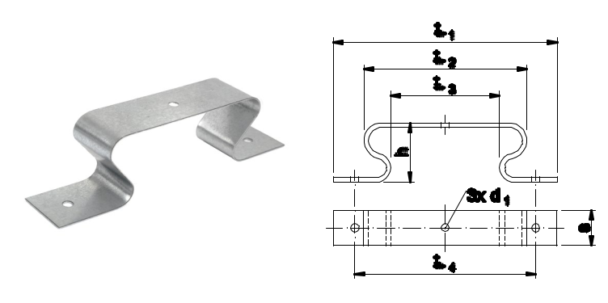

Use: the distance between the plates, mounted e.g. on tanks, boilers in the marine industry.

Availability: in stock

Logistic minimum: 400 pcs/package

MATERIAL: GALVANIZED STEEL

 |  | Name | ^{L}1 | ^{L}2 | ^{L}3 | ^{L}4 | s | ^{d}1 | h | Index
 |  | Omega Connector | 150 | 105 | 65 | 120 | 30 | 5,3 | 40 | T-08-001-12030

MATERIAL: STAINLESS STEEL 1.4301

 |  | Name | L₁ | L₂ | L₃ | L₄ | s | d₁ | h | Index
 |  | Omega Connector | 150 | 105 | 65 | 120 | 30 | 5,3 | 40 | T-08-002-12030

ADDITIONAL Other dimensions and materials are available on request.

INFORMATION

45

TAPES | FABRICS | INSULATION | INSULATION | FASTENING | SD STUDS CABLE TRAYS | OTHERS
 |  | FASTENERS | MATTRESSES | TECHNIQUES

TERMIKA WOOL HOOKS

Material: galvanized steel
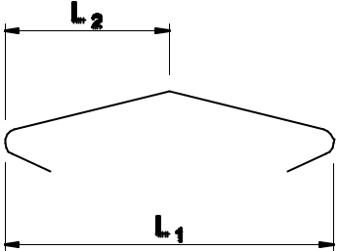

Use: connection of the insulation mats to eliminate the thermal bridge and reducing heat loss as well as securing the formwork sheet metal against excessive heating up.
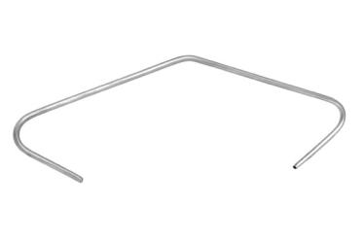

Availability: in stock

Minimum logistyczne: 400 pcs./package

MATERIAL: GALVANIZED STEEL

 |  | Name | L₁ | L₂ | ø | Index
 |  | Termika wool hooks | 115 | 60 | 2 | T-08-003

ADDITIONAL INFORMATION

Other dimensions and materials are available on request.

100pcs in package.

46

INSULA TION TECHNIQUE

TAPES | FABRICS | INSULATION | INSULATION | FASTENING | SD STUDS CABLE TRAYS | OTHERS
 |  | FASTENERS | MATTRESSES | TECHNIQUES

ISOLA WIRE MESH

Material: galvanized steel
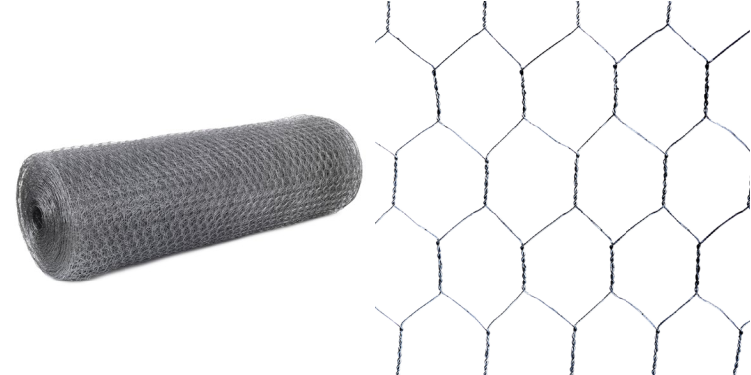

Use: Isola mesh has a versatile application. Among other things, it is used in the construction as reinforcement for lime cement and gypsum renders and insulation. It is also used as a fence for small animals. It works as a protection against pests for gardeners and farmers as well as against predators in bird breeding. It can also be used as a cover for trees and shrubs and as a support for climbers.

Availability: in stock

PRODUCT CHARACTERISTICS

 |  | Hexagonal mesh | 25x25mm
 |  | Wire thickness | 0,66mm+/-0,01mm
 |  | Roll width | 1000mm
 |  | Roll length | 50m
 |  | Tensile strength | 35-45kg/mm2
 |  | Zinc coating | 40-5-g/m2

ADDITIONAL Packing: roll - 50 m2 / pallet - 1000 m2.

INFORMATION

47

TAPES | FABRICS | INSULATION | INSULATION | FASTENING | SD STUDS CABLE TRAYS | OTHERS
 |  | FASTENERS | MATTRESSES | TECHNIQUES

THREADED ROD CONNECTOR

Material: galvanized steel
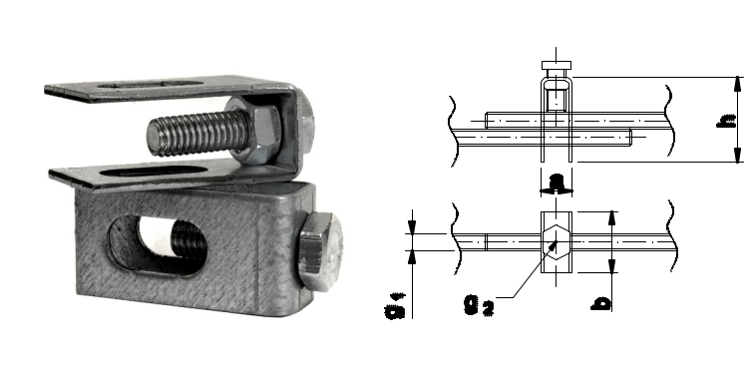

Application: a connector designed to connect two threaded rods of the same diameter.

Characteristics: adjustable connection, detachable connection, quick assembly, high durability

Availability: on request

MATERIAL: GALVANIZED STEEL

 |  | Name | a | b | ^{g}1 | ^{g}2 | h | Index
 |  | Connector m6 | 14 | 17 | M6 | M6 | 33 | T-08-006
 |  | Connector m8 | 14 | 17 | M8 | M6 | 33 | T-08-008
 |  | Connector m10 | 14 | 17 | M10 | M6 | 33 | T-08-010
 |  | Connector m12 | 23 | 23 | M12 | M10 | 48 | T-08-012

ADDITIONAL Other dimensions and materials are available on request.

INFORMATION

48

INSULA TION TECHNIQUE

TAPES | FABRICS | INSULATION | INSULATION | FASTENING | SD STUDS CABLE TRAYS | OTHERS
 |  | FASTENERS | MATTRESSES | TECHNIQUES

BALL BAND

Material: polyethylene
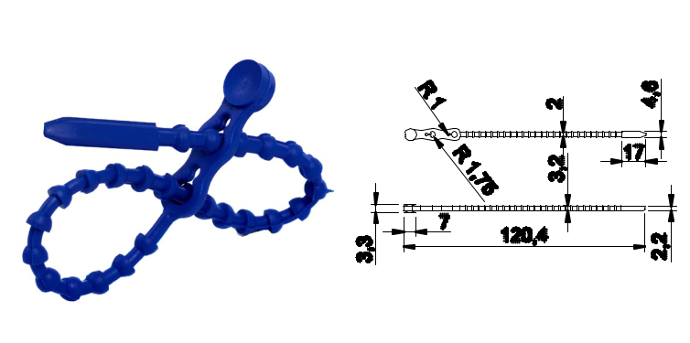

Use: reusable headband used in places requiring the cable harness to be re-shorted, double harness, label hanging, attachment of nameplates, etc.

Characteristics: available colors: colorless, blue, red, white; disconnected connection

Availability: on request

MATERIAL: POLYETHYLENE

 |  | Name | Length (mm) | Width (mm) | Index
 |  | Ball band | 120 | 3,5 | T-09-001

49

TAPES | FABRICS | INSULATION | INSULATION | FASTENING | SD STUDS CABLE TRAYS | OTHERS
 |  | FASTENERS | MATTRESSES | TECHNIQUES

PIPE BLANK COVER

Material: polyethylene
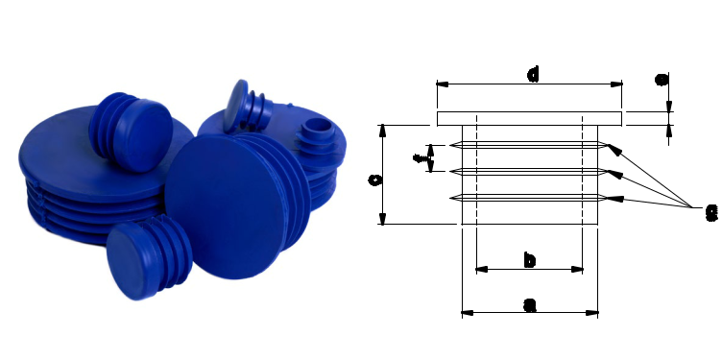

Application: in the furniture industry, machinery and construction industries they are used in steel profile constructions, fence systems, furniture.

Characteristics: available in colours: colourless, blue, red, white

Availability: on request

MATERIAL: POLYETHYLENE

 |  | Name | c mm | a mm | b mm | h mm | d mm | e mm | f mm | g pc. | Index
 |  | c-8 | 8 | 5 | - | 9,5 | 13 | 2 | 3,5 | 2 | t-09-008
 |  | c-10 | 10 | 7 | 5 | 9,5 | 15 | 2 | 3,5 | 2 | t-09-010
 |  | c-13 | 13 | 10 | 8 | 12 | 18 | 2 | 3,5 | 2 | t-09-013
 |  | c-15 | 15 | 12 | 10 | 13 | 20 | 2 | 3,3 | 3 | t-09-015
 |  | c-17 | 17 | 14 | 12 | 13 | 22 | 2 | 3,8 | 3 | t-09-017
 |  | c-18 | 18 | 15 | 12,8 | 13 | 23 | 2 | 3,8 | 3 | t-09-018
 |  | c-20 | 20 | 17 | 15 | 12,5 | 22,5 | 4,6 | 3,8 | 3 | t-09-020
 |  | c-22 | 22 | 19 | 16 | 15 | 28 | 2 | 4 | 3 | t-09-022
 |  | c-24 | 24 | 21 | 17,5 | 15 | 30 | 2 | 4,2 | 3 | t-09-024
 |  | c-25 | 25 | 22 | 18,5 | 15 | 31 | 2 | 4,2 | 3 | t-09-025
 |  | c-26 | 26 | 23,5 | 19,5 | 15 | 32 | 2 | 4,2 | 3 | t-09-026
 |  | c-28 | 28 | 25 | 21,5 | 15 | 34 | 2 | 4,5 | 3 | t-09-028
 |  | c-30 | 30 | 27 | 24 | 15 | 36 | 2 | 4,5 | 3 | t-09-030
 |  | c-32 | 32 | 28,5 | 24,5 | 15 | 38 | 2 | 4,5 | 3 | t-09-032
 |  | c-34 | 34 | 30,5 | 27,5 | 18,5 | 40 | 2 | 4,5 | 4 | t-09-034
 |  | c-36 | 36 | 33 | 29,5 | 19 | 42 | 2 | 4,5 | 4 | t-09-036
 |  | c-45 | 45 | 37,5 | 30,5 | 17 | 48,5 | 2 | 4,7 | 3 | t-09-045
 |  | c-50 | 50 | 45,5 | 42 | 18 | 54,5 | 3 | 4 | 4 | t-09-050
 |  | c-80 | 80 | 72,5 | 68 | 16,5 | 85,5 | 3 | 5,5 | 3 | t-09-080

50

INSULA TION TECHNIQUE

TAPES | FABRICS | INSULATION | INSULATION | FASTENING | SD STUDS CABLE TRAYS | OTHERS
 |  | FASTENERS | MATTRESSES | TECHNIQUES

SERVICES

The scope of our company’s activity includes sales of materials for the marine industry, land industry, offshore, construction as well as services in the field of:

 |  | projects | supervision
 |  | technical documentation | quality control
 |  | overseeing the built | warranty and post-warranty services
 |  | workmanship and delivery of materials

We conduct retail and wholesale trade of thermal insulation materials and specialized construction chemicals.

We are one of the most important trade partners in this area in northern Poland.

RANGE OF DISTRIBUTION OF GOODS

Our customers:

Polish, European Insulation companies

and world shipyards in Poland and Europe

The largest construction Manufacturers of air conditioning

companies in Poland and ventilation

Stores and construction Companies from road and

wholesale bridge construction industry

Companies from Companies from

automotive industry defense industry

Companies from Companies from

the railway industry the food industry

51

